Pupil Feedback Booklet

Jennett's Park C of E Primary School

Introduction
This booklet summarises the views and experiences of our pupils across all year groups. It captures what makes learning enjoyable, identifies areas for improvement, and reflects on teaching quality, safety, behaviour, and wellbeing. These insights represent the diverse voices of our school community and will help shape our future development.

🎓 What Makes Learning Enjoyable
Our pupils have told us they most enjoy:

Practical and Hands-On Learning
- Building toy cars
- Conducting science experiments
- Using manipulatives in maths

Creative Expression
- Art, drama, and music lessons
- Opportunities for self-expression
- Calming and exciting creative experiences

Technology in Learning
- Using iPads for research
- Educational games
- Interactive learning activities

Working Together
- Partner work
- Group activities
- Collaborative learning that deepens understanding

Memorable Experiences
School Trips:
- PGL residential
- Windsor Castle
- Sea Life Centre
Special Days:
- Pirate Day
- Roman Day
- Ramadan celebrations
- Pause Day

Physical Activity
- PE lessons
- Sports events
- The daily mile
- Fun and fitness combined

🛠️ Areas for Improvement
Our pupils have identified the following areas where they would like to see changes:

Curriculum Balance
- More variety and choice in topics
- Greater freedom in choosing writing genres and art projects
- More computing, DT, and PE
- Less repetitive writing tasks

Facilities and Environment
- Improvements to school meals
- Better bathroom facilities
- Enhanced playground equipment

Learning Support
- More tailored support for different ability levels
- Additional challenge for higher-ability learners
- Continued support for those who need extra help

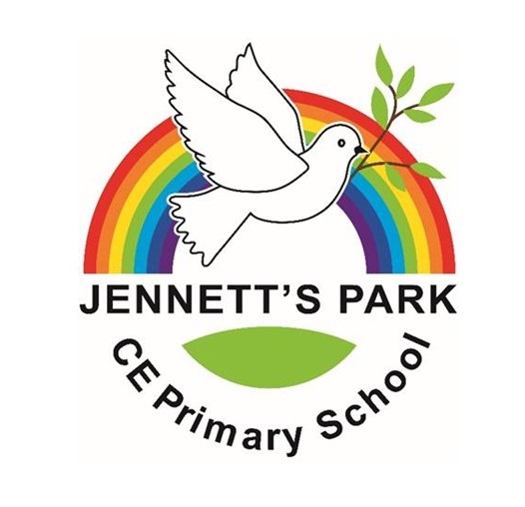
🌟 Favourite Experiences

Residential Trips
- PGL - repeatedly cited as a highlight
- Little Canada - memorable and enjoyable

Workshops and Special Events
- Science Lego workshops
- Cultural celebrations
- Themed learning days

Educational Visits
- Museum trips
- Castle visits
- Historical learning experiences that bring topics to life

👩‍🏫 Teaching and Learning Quality

What Works Well
Engaging Lessons
- Fun and interactive teaching approaches
- Varied activities that maintain interest
Clear Feedback
- Helpful marking
- Verbal feedback
- Tools like Olex AI to support improvement
Supporting Independence
- Working walls
- Checklists
- Self-assessment opportunities
Appropriate Challenge
- Many pupils enjoy being challenged
- Recognition that difficulty levels could be better tailored to individual needs

🛡️ Safety and Wellbeing

Feeling Safe
Our pupils report feeling safe because of:
- Secure gates and premises
- Trusted adults to talk to
- E-safety education

Emotional Support
Key sources of comfort and support:
- Teachers
- Friends
- School counselling services

School Values
Our Rainbow Values underpin:
- A culture of kindness
- Mutual respect
- Inclusion for all

🧒 Behaviour and Conduct

Positive Behaviour
- Generally good behaviour in classrooms
- Respectful conduct on the playground
- Strong understanding of expectations

Areas for Growth
- Occasional disruptions noted
- Some unkind behaviour during unstructured times
- Continued focus needed on consistency

Recognition and Rewards
Pupils appreciate:
- Stickers and certificates
- Celebration assemblies
- Motivating reward systems

🗣️ Pupil Voice and Leadership

Opportunities to Contribute
Pupils value their roles in:
- School Council
- Eco Council
- Worship Council
- Prefect positions

Being Heard
- Many pupils feel their ideas are listened to
- Some would like to see more action taken on feedback
- Continued development of pupil voice mechanisms

🥦 Health and Fitness

Staying Active
- PE lessons
- Sports clubs
- The daily mile
- Regular physical activity opportunities

Healthy Eating
Mixed Feedback on School Meals:
- Some praise for healthy options
- Suggestions for improvements in taste
- Requests for better portion sizes

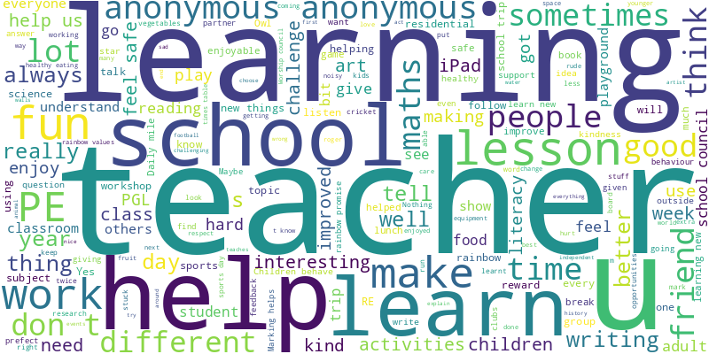

📈 What's Improved
Pupils have noticed positive changes:
- More engaging and practical lessons
- Increased opportunities for trips and enrichment
- Better behaviour and classroom atmosphere in many areas
- Enhanced learning experiences

📌 Next Steps: Our Commitment
Based on your feedback, we will focus on:

1.

Variety and Choice
- Expanding options in learning activities
- Providing more choice in topics and projects
- Balancing the curriculum more effectively

2. Creative and Practical Subjects
- Increasing access to computing, DT, and PE
- Enhancing creative learning opportunities
- Maintaining hands-on learning experiences

3. Facilities and Environment
- Continuing to improve school meals
- Upgrading playground equipment
- Enhancing learning spaces

4. Personalised Learning
- Providing more tailored support
- Offering appropriate challenge for all learners
- Ensuring every child can achieve their potential

5. Pupil Voice
- Acting on your feedback
- Strengthening pupil leadership opportunities
- Ensuring you see the impact of your suggestions

Thank You
Thank you to all pupils who shared their views. Your voice matters, and this feedback will help us continue to improve Jennett's Park C of E Primary School for everyone.
Together, we will continue to make our school an even better place to learn, grow, and thrive.

