Red/Blue update
3.3.26
Dear Parents and Carers
We want to make you aware that schools nationally are seeing a rise in a trend referred to as ‘Red/Blue’.
While we have no significant concerns within our school at this stage, we are reminding students of the importance of respectful behaviour, online awareness, and speaking to a trusted adult if they feel pressured or worried.
Please continue to support your child by discussing how they can stay safe and make positive choices. Do contact us via secretary@ if you are worried.
Kind regards
Team JPCE

Yours sincerely
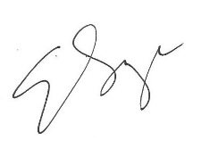
Liz Savage
Headteacher of Jennett’s Park CE Primary

