Jennett’s Park CE Primary

Restrictive Interventions & Use of Reasonable Force Policy



Date reviewed | Updated January 2026 in line with new DfE guidance (effective 1 April 2026)
Date of Next review | April 2028
Published | Draft
Website Status | Yes

Jennett’s Park CE Primary School Restrictive Interventions &Use of Reasonable Force Policy

Contents
School Background: 3
Rationale 3
2. Definitions 4
2.1 Reasonable Force 4
2.2 Restrictive Intervention 4
What is reasonable force? 5
3. Guiding Principles 5
3.1 Prevention First 5
3.2 Safeguarding 8
3.3 Dignity and Respect 8
3.4 Trauma-Informed Practice 8
3.5 Least Restrictive Option 8
4. When Physical Intervention May Be Used 8
5. Alternative Strategies 9
6.When physical intervention becomes necessary: 9
DO 9
DO NOT 9
7. Authorised Staff 10
Positive Handling for Staff Working with Children (primary) 10
8. Use of Physical Intervention 10
9. After an Incident 10
9.1 Immediate Actions 11
9.2 Debriefing 11
10. Recording and Reporting (New Statutory Duty from Sept 2025) 11
10.1 Significant incidents must be recorded and reported to parents. 11
10.2 Recording 11
10.3 Reporting to Parents 12
10.4 Data Monitoring 12
10. Risk Assessments & Individual Plans 12
11. Complaints 12
12. Monitoring and Review 12

School Background:

Jennett’s Park CE Primary School is an inclusive Christian school, welcoming all children from the whole community to a caring and happy environment where they can achieve to the very best of their abilities. At Jennett’s Park CE we believe that all children are unique and we encourage them to develop their strengths and creativity as individuals. We emphasise the development of the whole-learner physically, intellectually, emotionally and ethically. We wish for children to flourish and achieve under God’s Love.

We promise as a staff and community to try to serve the common good with our work as part of the Church of England.

Educating for Wisdom, Knowledge and Skills | To help grow resourceful , resilient and reflective children who are equipped with the skills , knowledge and tenacity empower themselves, their learning throughout their lives.
Educating for Hope and Aspiration | To inspire and enrich lives beyond current opportunities and experiences in order to open minds to the potential their future holds
Educating for Community and Living Well Together | To be a multi-cultural, inclusive community of individuals loved by God who feel valued and involved where we create qualities of character to enable people to flourish.
Educating for Dignity and Respect | That children might know how much that they are loved and valued by so that they might show dignity and respect for themselves and others by carefully and safely thinking through their actions.

Rationale:
Jennett’s Park CE Primary School is committed to creating a safe, nurturing environment where children flourish academically, socially, emotionally, and spiritually. Physical intervention is used only when absolutely necessary to prevent harm and always in a way that upholds dignity, safety, and our school Rainbow values.
Pupils will receive quality care which recognises and caters for their individual needs as far as is appropriate in mainstream school. School rules will work to keep all adults and children safe and provide firm boundaries and limits as well as setting out the sanctions that follow breaking them. Parents will be kept informed about breaches of rules as per the behaviour policy and always when significant physical intervention has been necessary.
This policy reflects:
- DfE: Restrictive interventions, including the use of reasonable force, in schools (effective 1 April 2026)
- New statutory duty to record and report all significant incidents involving force (from September 2025)
- Relevant legislation including the Education and Inspections Act 2006, Children Acts 1989 & 2004, Equality Act 2010, Health & Safety at Work Act 1974.

2. Definitions

2.1 Reasonable Force
“Reasonable force” refers to the minimum physical force necessary to prevent a pupil from:
- Causing harm to themselves or others
- Causing significant damage to property
- Seriously disrupting learning or the safe running of the school
- Leaving a supervised area when doing so would place them at risk
Force must always be:
- Proportionate
- Necessary
- Time-limited
- In the child’s best interests
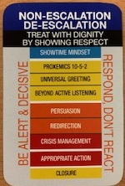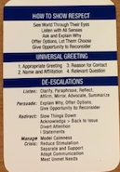

2.2 Restrictive Intervention
A restrictive intervention is any action that restricts a pupil’s movement, including physical restraint. It is used only when:
- There is immediate risk of harm, and
- All less restrictive options have been exhausted or are not viable

What is reasonable force?

1. The term ‘reasonable force’ covers the broad range of actions used by most teachers at some point in their career that involve a degree of physical contact with pupils.
2. Force is usually used either to control or restrain. This can range from guiding a pupil to safety by the arm through to more extreme circumstances such as breaking up a fight or where a student needs to be restrained to prevent violence or injury.
3. ‘Reasonable in the circumstances’ means using no more force than is needed.
4. As mentioned above, schools generally use force to control pupils and to restrain them. Control means either passive physical contact, such as standing between pupils or blocking a pupil's path, or active physical contact such as leading a pupil by the arm out of a classroom.
5. Physical intervention means to hold back physically or to bring a pupil under control. It is typically used in more extreme circumstances, for example when two pupils are fighting and refuse to separate without physical intervention.

3. Guiding Principles
Staff at Jennett’s Park Primary School recognise that the use of reasonable force is only one of the strategies available to secure pupil safety / well-being and also to maintain good order and discipline. Our policy on physical intervention should therefore be read in conjunction with our Behaviour and Child Protection policies.

Physical intervention should avert danger by preventing or deflecting a child’s action or perhaps by removing a physical object, which could be used to harm him / herself or others. It is only likely to be needed if a child appears to be unable to exercise self-control of emotions and behaviour.

Staff will not physically use a hold to get children into school. Parents and carers need to be able to get their child into school without physical assistance from staff.

It is not possible to define every circumstance in which physical intervention would be necessary or appropriate and staff will have to exercise their own judgement in situations which arise within the above categories. Staff should always act within the School’s policy on behaviour and discipline, particularly in dealing with disruptive behaviour.

Staff should be aware that when they are in charge of children during the school day, or during other supervised activities, they are acting in loco parentis and should, therefore, take reasonable action to ensure pupils’ safety and wellbeing.

Failure to physically restrain a pupil who is subsequently injured or injures another, could, in certain circumstances, lead to an accusation of negligence
In line with the DfE guidance, Jennett’s Park CE Primary commits to:

3.1 Prevention First
Staff prioritise early intervention, de-escalation, and relational practice to reduce the need for physical intervention.
We understand that in a rapidly escalating situation the balance is to look to reasonable care. Would doing nothing be neglectful? Would jumping in be recklessly heroic?

3.2 Safeguarding
The welfare of pupils and staff is paramount. Any use of force must protect—not compromise—safety.

3.3 Dignity and Respect
Children must never be humiliated, punished, or deprived of basic needs.

3.4 Trauma-Informed Practice
Staff consider the child’s history, communication needs, SEND profile, and emotional state.

3.5 Least Restrictive Option
Physical intervention is a last resort. Staff should use the least restrictive option.

4. When Physical Intervention May Be Used
Any member of staff in school may use reasonable force to:
- Prevent a pupil from harming themselves or others
- Stop a fight
- Prevent dangerous behaviour (e.g., running into a road)
- Prevent serious damage to property
- Remove a pupil from a situation where they refuse to leave and remaining poses a risk
- Prevent behaviour that significantly disrupts learning or a school event
Schools cannot:
- Use force as a punishment – it is always unlawful to use force as a punishment.
Staff must not use force:
- As a punishment
- To inflict pain
- In a way that restricts breathing or blood flow
- In a way that is degrading or abusive

5. Alternative Strategies
Staff use a wide range of preventative and de-escalation strategies, including:
- Calm, non-confrontational communication
- Use of space and movement
- Distraction and redirection
- Offering choices
- Adjusting the environment
- Use of humour
- Withdrawal of audience
- Supportive adult presence
- Regulation strategies
6.When physical intervention becomes necessary:

DO
- Identify hazards and people likely to come into contact with them.
- Tell the pupil what you are doing and why.
- Prompt positive responses.
- Control the environment, issue clear guidance, provide training and change working practices to reduce exposure.
- Use the minimum force necessary.
- Involve another member of staff if possible.
- Tell the pupil what they must do for you to remove the physical intervention (this may need frequent repetition).
- Use simple and clear language and direction.
- Use holds learned in Dynamis Physical intervention training.
- Relax your physical intervention in response to the pupil’s compliance.

DO NOT
- Act in temper (involve another staff member if you fear loss of control).
- Involve yourself in a prolonged verbal exchange with the pupil.
- Involve other pupils in the physical intervention.
- Touch or hold the pupil in sexual areas.
- Twist or force limbs back against a joint.
- Bend fingers or pull hair.
- Hold the pupil in a way which will restrict blood flow or breathing e.g. around the neck.
- Slap, punch, kick or trip up the pupil.

7. Authorised Staff
All staff and extension to those supporting in school and on trips may use reasonable force when necessary. Training is refreshed annually and recorded. We have many staff trained in Dynamis Positive Handling may use restrictive holds.

Positive Handling for Staff Working with Children (primary)
Current list as of January 2026
Bobby Killick
Carla Szadowski
Catherine Butcher
David Page
Elise Woodhall
Freya Howarth
Gemma Robinson
Jen Allen
Liz Savage
Marie Manthorpe
Natasha Smith
Sam Edwards
Shazia Hussain
Shelley Thorpe
Sophie Andrews

8. Use of Physical Intervention
When physical intervention is required, staff must:
- Use the minimum force for the shortest time
- Communicate clearly with the pupil
- Continually assess risk
- Release the hold as soon as the pupil regains self-control
- Avoid holds that restrict breathing, circulation, or cause pain
- Seek assistance from another adult wherever possible

9. After an Incident
Physical intervention often occurs in response to highly charged emotional situations and there is a clear need for debriefing after the incident, both for the staff involved and the pupil. A member of the leadership team should be informed of any incident as soon as possible and will take responsibility for making arrangements for debriefing once the situation has stabilised. An appropriate member of the teaching staff should always be involved in debriefing the pupil involved and any victims of the incident should be offered support, and their parents informed.

If the behaviour is part of an ongoing pattern it may be necessary to address the situation through the development of an Individual Behaviour Support & Intervention plan or positive handling plan, which may include an anger management programme, or other strategies agreed by the SENCO or pastoral team.

It is also helpful to consider the circumstances precipitating the incident to explore ways in which future incidents can be avoided.

All incidents should be recorded immediately on my concern software. A member of the leadership team will contact parents as soon as possible after an accident, to inform them of the actions that were taken and why, and to provide them with an opportunity to discuss it.

9.1 Immediate Actions
- Check for injuries
- Provide first aid if required
- Offer emotional support to the pupil and any others involved
- Remove the audience and stabilise the environment

9.2 Debriefing
A member of the leadership team leads a debrief with:
- The pupil
- Staff involved
- Witnesses (if appropriate)
Debriefing focuses on learning, not blame.

10. Recording and Reporting (New Statutory Duty from Sept 2025)
In line with the new DfE requirement:

10.1 Significant incidents must be recorded and reported to parents.
A “significant incident” includes any use of force that:
- Restricts movement- this is different from holds moving locations though should still be recorded.
- Causes injury or distress
- Involves repeated use with the same pupil
- Occurs as part of a pattern of behaviour
- Requires medical attention
- Raises a safeguarding concern
We also aim to record use of barriers and removals to isolation in the same way

10.2 Recording
Staff must complete a my concern to state Physical Intervention Record on the same day where possible. Staff to comment where possible on Outline of event leading to physical intervention, decisions on de-escalation, Proxemics , Outline of incident of physical intervention (including physical intervention method used), Outcome of physical intervention, Description of any injury sustained and any subsequent treatment on ‘My concern.’ The team will allocate correct category – high medium or low and for significant incidents report to parents.

10.3 Reporting to Parents
Parents must be informed as soon as reasonably practicable, ideally within 24 hours.

10.4 Data Monitoring
Senior leaders and governors review patterns, frequency, and context of incidents to ensure safety, equity, and compliance.

10. Risk Assessments & Individual Plans
If we become aware that a pupil is likely to behave in a disruptive way that may require the use of reasonable force, we will plan how to respond if the situation arises . For pupils with predictable or high-risk behaviours, the school will create:
- Individual Behaviour Support Plans
- Positive Handling Plans
- Risk Assessments
. Such planning will address:
- Management of the pupil (e.g. reactive strategies to de-escalate a conflict, holds to be used if necessary).
- Involvement of parents to ensure that they are clear about the specific action the school might need to take and contribute from their experience.
- Briefing of staff to ensure they know exactly what action they should be taking (this may identify a need for training or guidance).
- Identification of additional support that can be summoned if appropriate.
These are co-produced with parents and relevant professionals.

11. Complaints
A clear physical intervention policy, adhered to by all staff and shared with parents, should help to avoid complaints from parents. It is unlikely to prevent all complaints, however, and a dispute about the use of force by a member of staff might lead to an investigation, either under disciplinary procedures or by the Police and social services department under child protection procedures.
Complaints are handled through the school’s Complaints Policy. All records will be available for scrutiny by safeguarding partners, governors, and external agencies if required.

12. Monitoring and Review
This policy will be reviewed biannually or sooner if:
- DfE guidance changes
- There is a significant incident
- Monitoring identifies a need for revision

Appendix 1 Letter to Parents / Carers Following Use of Physical Intervention with a Student
While our focus should always be on de-escalation, there may be occasions when a member of staff in your school feels it is reasonable, proportionate and necessary to use a restrictive intervention in order to keep everyone safe.
In these situations, it is vital to keep parents and carers fully informed about what has happened, and ensure they are offered the opportunity to discuss the incident with any relevant staff members. Open, two-way communication underpins the restorative process, enabling schools and families to work collaboratively to find ways forward together.
A 3-step approach to support
It can be upsetting for parents and carers to find out that a physical intervention has been used to support their child. They may feel angry, worried, confused or frustrated about why the intervention was necessary, and what will happen in future to reduce the likelihood of it happening again.
It’s helpful to put a robust 3-step system in place following the use of any restrictive practice so you can inform and support families and ensure they are part of decision-making processes:

In-Person/ Phone Call
As soon as possible, let parents / carers know what has happened, either in person or over the phone. Where there is a face-to-face meeting, this should take place in a quiet, private and comfortable space, to ensure confidentiality. This conversation is an opportunity to clarify the reasons for the intervention, allay any fears, and offer reassurance.

Written Follow-Up
After talking about the incident, write a letter (see template example) that provides details of the incident explaining what will happen next to move forward together. You may also want to share the policy so that parents / carers can understand more about behaviour support strategies used in school.

Planned Meeting
Set up a meeting with the parents / carers to identify ways to avoid similar situations happening in the future, and to review and update individual risk assessments and support plans. If appropriate, you may also want to involve the student and any relevant staff members. This can form part of a wider restorative process, to encourage the repairing of damaged relationships and to promote a culture of post-incident reflection and support.

Appendix 1a Letter Template for Parents / Carers Following the Use of a Physical Intervention with a Student

*Please transfer the contents of this letter onto headed paper with your school’s logo and contact information.
Dear [insert parent / carer name]
Further to our conversation, here are the details of the recent incident involving your child:

Date, time, duration, and location of the incident | Insert the date, time, duration, and location of the incident
Details of the incident | Include:  - names of the student and staff involved  - relevant student needs or circumstances, including SEND status  - brief summary of the incident: lead-up, triggers (if known), de-escalation attempts, type and degree of intervention used, and any injuries  - rationale for why intervention was deemed necessary  - post-incident support, including medical treatment or other impacts
We understand that you may be feeling worried or upset about what has happened. Please be reassured that the safety and wellbeing of your child is always our priority and physical interventions are only used as a last resort in order to keep everyone safe. Our policy explains more about the ways we support your child at school.
We would like to find a convenient time to discuss what we can do to reduce the likelihood of this happening again and find the best ways to support your child moving forward.
Please get in touch to let us know when you would be available to meet [insert contact details].
If you have any concerns about your child’s physical, emotional or mental wellbeing as a result of this incident, or want to ask any questions, please do get in contact. If you are worried about your child’s health, especially in relation to any physical symptoms, please contact your doctor immediately.
Yours sincerely
[add staff member / head teacher’s name]

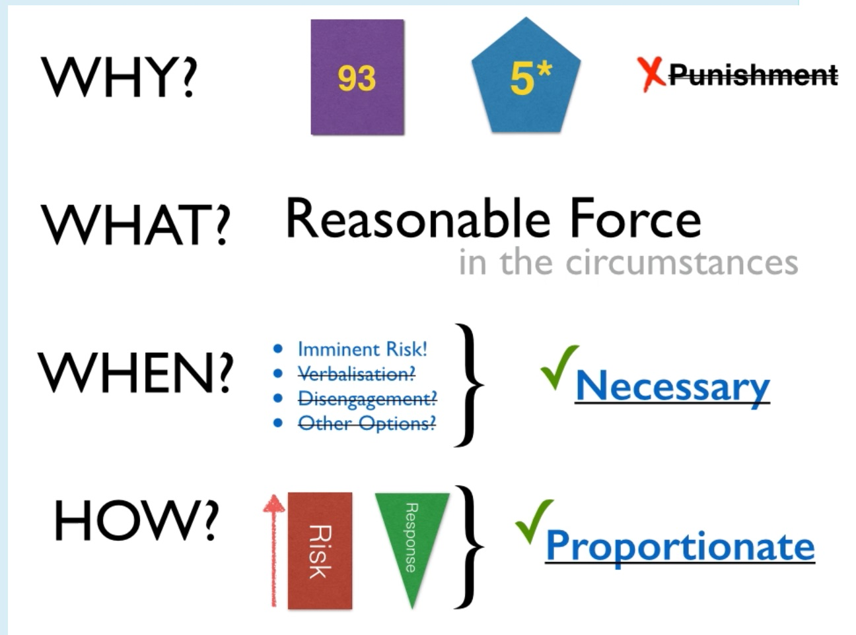
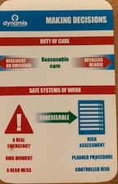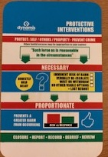
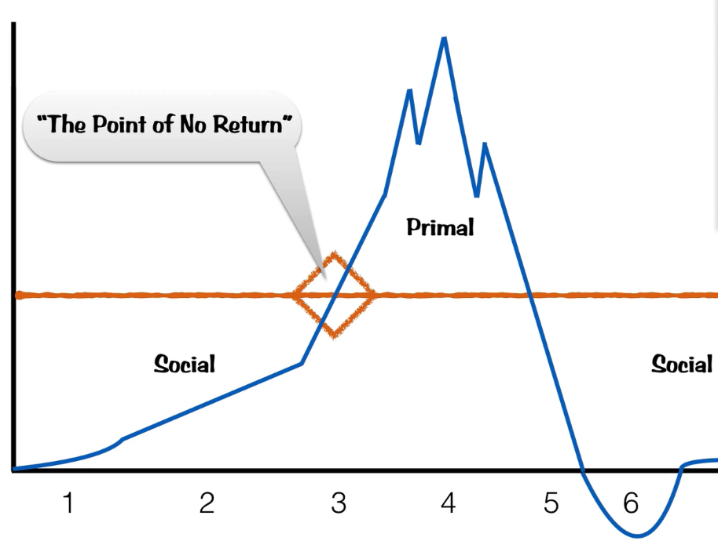
Vesibular reflex – ie the self protection type of brain taking over

 