Jennett’s Park CE Primary

Nutrition Policy

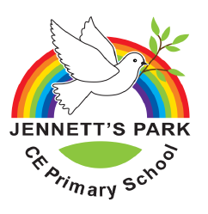

Date reviewed | January 26
Date of Next review | January 2029
Published | Draft
Website Status | Yes

Jennett’s Park CE Primary School Nutrition Policy
Contents
School Background: 2
1. Purpose and Scope 3
2. Our Commitment to Healthy Nutrition 3
3. What We Provide 3
Drinks 3
Snacks 4
School Meals 4
4. What Parents/Carers Provide 4
Drinks 4
Snacks 4
Packed Lunches 4
5. Special Dietary Requirements 5
Food Allergies 5
Children with Additional Support Needs 5
6. Food Safety 5
Choking 6
7. Working with Parents and Carers 6
Healthy and Balanced Diet 6
The Eatwell Guide 7
8. Birthdays and Celebrations 7
9. Roles and Responsibilities 7
All staff must: 7
The EYFS Leader will: 8
Parents/Carers should: 8

School Background:

Jennett’s Park CE Primary School is openly inclusive Christian school, welcoming all children from the whole community to a caring and happy environment where they can achieve to the very best of their abilities. At Jennett’s Park CE we believe that all children are unique and we encourage them to develop their strengths and creativity as individuals. We emphasise the development of the whole-learner physically, intellectually, emotionally and ethically. We wish for children to flourish and achieve under God’s Love.

We promise as a staff and community to try to serve the common good with our work as part of the Church of England.

Educating for Wisdom, Knowledge and Skills | To help grow resourceful , resilient and reflective children who are equipped with the skills , knowledge and tenacity empower themselves, their learning throughout their lives.
Educating for Hope and Aspiration | To inspire and enrich lives beyond current opportunities and experiences in order to open minds to the potential their future holds
Educating for Community and Living Well Together | To be a multi-cultural, inclusive community of individuals loved by God who feel valued and involved where we create qualities of character to enable people to flourish.
Educating for Dignity and Respect | That children might know how much that they are loved and valued by so that they might show dignity and respect for themselves and others by carefully and safely thinking through their actions.

1. Purpose and Scope

From September 2025, there is a requirement in the Early Years Foundation Stage (EYFS) statutory framework that early years providers should have regard to the DfE’s Nutrition Guidance. Providers must follow this guidance unless there's a good reason not to.

Nutrition Guidance: https://assets.publishing.service.gov.uk/media/6839b752210698b3364e86fc/Early_years_foundation_stage_nutrition_guidance.pdf

This policy applies to food and drink provided to children in our early years provision and reflects our commitment to the EYFS Statutory Framework requirement that 'where children are provided with meals, snacks and drinks, these must be healthy, balanced and nutritious'.

2. Our Commitment to Healthy Nutrition

At Jennett's Park CofE Primary School, we know that the early years are a crucial time to set the foundations for a lifetime of good health. We are committed to:
- Supporting all children to access the nutrients and energy they need while they are growing rapidly.
- Helping children develop positive eating habits early on, as children's early experiences with food can shape future eating habits and impact their long-term health.
- Encouraging children to eat a balanced diet containing a wide variety of foods.
- Creating an inclusive environment that respects all dietary requirements.

We avoid making children: finish everything on their plate; eat more than they want to; offering rewards to children for finishing food (e.g. stickers or dessert). Instead, we encourage children to think: “Have I had enough to eat? Am I still hungry?”

If we are worried about a child and their health, their diet or their food consumption, we will always speak with parents/carers. We also encourage parents/carers to speak to a member of staff if they have any concerns about their child’s health or diet.

3. What We Provide

Drinks
- We only provide fresh tap water and plain cows’ milk for children to drink.
- All taps in the classrooms contain drinking water and children are able to refill their own bottles as required.
- We will not provide or refill children’s drink bottles with sugary drinks (e.g. fruit juices, squash).
- Under the Nursery Milk Scheme for the under 5s, we will offer cows’ milk to children if parents/ carers have confirmed their child can consume dairy milk.

Snacks
- Children will be offered a snack consisting of one portion of fruit or vegetable, at least once per day.
- Snack foods offered will regularly include, for example, apples, bananas, pears, satsumas, carrots, tomatoes, sugar-snap peas. On occasion snack foods may include, for example, breadsticks, rice cakes, crackers.
- Snacks will not include dried fruit such as raisins.

School Meals
- Children in Reception can choose to order a school lunch each day. School meals are provided by Harrisons Catering Services.
- All school meals adhere to strict Government guidance on food groups and portion sizes.

Further information about school meals, including allergies, can be found on the school website: https://www.jennetts.bonitas.org.uk/school-office/school-meals/

4. What Parents/Carers Provide

Drinks
- We ask all parents/carers to provide a named bottle for their child to use during the day.
- Children’s drinking bottles should contain water.
- Children’s drinking bottles are sent home each day to be washed.
- Parents/carers are able to provide an alternative plain milk for their child if they wish to do so. This should be provided in a named carton or drinking bottle, and, can be kept refrigerated if required.

Snacks
- Parents/carers do not need to provide any snack food.
- If there is a medical reason your child may need access to a snack that is not typically available, please speak to your child’s class teacher who will be able to support you with this.

Packed Lunches
- Children in Nursery should be provided with a healthy packed lunch from home.
- Children in Reception may choose to bring a healthy packed lunch from home if they do not wish to order a school meal.
- We advise that parents/carers follow Government nutrition guidance when packing their child’s lunch to ensure their child eats a well-balanced and nutritious diet. Please see ‘Section 7 Working With Parents’ for more information.
- Lunchboxes should be clearly labelled with your child’s name.
- Portion sizes should be appropriate for a child’s age and appetite.
- There is no refrigeration available to store lunchboxes. Therefore, lunchboxes should only contain foods that can be safely stored at room temperature, or, food that has been packed with ice packs. If ice packs are not used, the ‘4-hour rule’ can be applied. This rule allows food to be stored outside of chilled conditions for up to 4 hours. However, this should only be done once during the storage, and any food that falls into this category and is not eaten by children at lunch, should be disposed of and not eaten later at home.
- Lunchboxes should not contain any nut products, including peanut butter and Nutella in sandwiches. We have individuals at school who suffer from nut-related anaphylaxis. Please double-check ingredients of items such as flapjacks, pesto etc to ensure they do not contain nuts.
- Lunchboxes should not contain items considered a choking hazard for the under 5s. This includes popcorn, whole grapes, marshmallows, uncut cherry tomatoes and unsliced hotdog sausages. Food must be prepared in a way to prevent choking. Please see this link for further information on choking hazards: https://www.food.gov.uk/sites/default/files/media/document/Early%20Years%20Choking%20Hazards%20Table_English.pdf
- Lunchboxes should not contain chocolate bars, sweets, fizzy drinks.
- We are unable to re-heat food.

5. Special Dietary Requirements

We cater for all children's dietary needs, including, food allergies and intolerances, religious and cultural dietary requirements and medical dietary needs.

We always aim to create a safe and inclusive environment for all children to eat and children with special dietary requirements are included in snack and meal times with other children as far as possible.

Food Allergies

We always speak with each family before any child starts with us in order to find out if their child has any food allergies or intolerances. The information shared is recorded and shared with the Medical Lead who ensures our medical system, Meditracker, reflects this information.

We have ongoing discussions with parents/carers and, where appropriate, health professionals to develop allergy action plans for managing any known food allergies and intolerances.

We always think about food allergies when food is being stored, delivered, sorted, prepared and cooked, and we avoid mixing foods that are safe with those that can cause allergic reactions.

Children with Additional Support Needs

If a child requires a special diet it is important to have written confirmation from their qualified health professional about the nature of their specific needs so that their nutritional requirements can be achieved.

Information shared by parents/carers should be recorded, updated regularly and communicated to all staff involved in the preparing and handling of food.

For children on a special diet, parents/carers and the registered dietitian should supply the details of the child’s dietary needs. This information should include suitable food choices for meals and snacks, foods that should be excluded or specifically included, and any supplements that may be required.

6. Food Safety

Key staff working with children in the EYFS hold full 12-hour Paediatric First Aid certificates and Food Hygiene certificates. For further information, please speak to your child’s class teacher.

At least one Paediatric First Aider is always in the room and present with the children when children in the EYFS are eating.

All staff follow food hygiene and safety procedures when preparing, storing and serving food.

Choking
- We follow the choking hazard advice from the Food Standards Agency and ensure that food served by staff is prepared appropriately to minimise any risk of choking.
- We do not serve food considered a choking hazard for the under 5s.
- At lunchtime, Nursery staff check lunchboxes before children access them and remove any items considered a choking hazard. Reception staff are vigilant to what children are eating at lunch time.

7. Working with Parents and Carers

We create strong, ongoing relationships with parents and carers to ensure clear communication about our approach to food provision. We work alongside parents/carers to ensure children are provided with healthy, balanced and nutritious food in the setting and at home.

This policy is in place to support our communication with parents/carers and to help them understand our regulatory obligation to provide healthy, balanced and nutritious food to children and encourage healthier food choices for packed lunches.

Healthy and Balanced Diet

A healthy and balanced diet is based on the four main food groups (fruit and vegetables; potatoes, bread, rice, pasta and other starchy carbohydrates; dairy or dairy alternatives; and beans, pulses, fish, eggs, meat and other proteins). These provide essential nutrients to help children grow and develop.

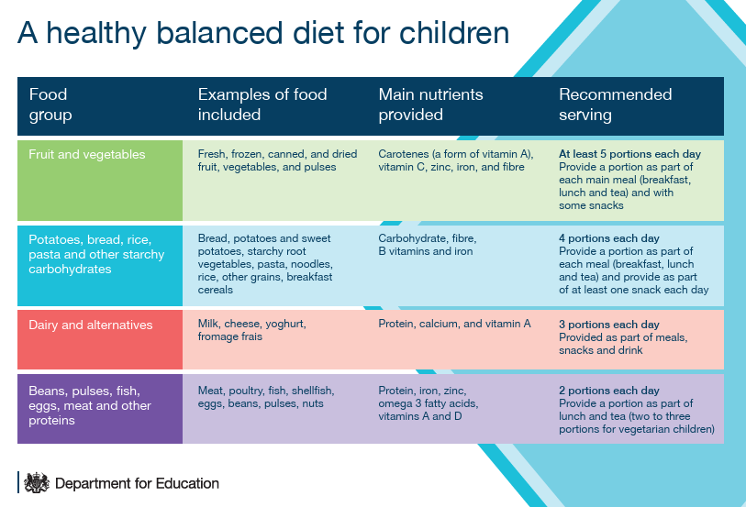

The Eatwell Guide

Children aged 3 to 5 years have different nutritional requirements to adults. They need to be fed a balanced diet with a range of foods. The Eatwell Guide uses government advice to show what a healthy and balanced diet looks like.

https://assets.publishing.service.gov.uk/media/5bbb790de5274a22415d7fee/Eatwell_guide_colour_edition.pdf
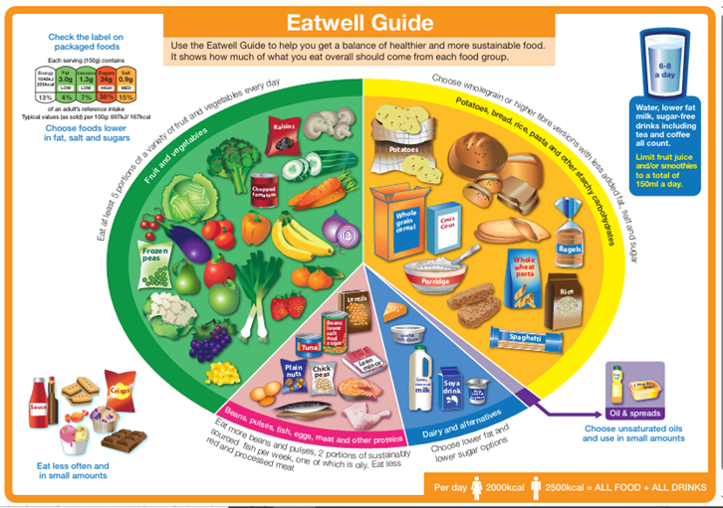

8. Birthdays and Celebrations

The Nutrition Guidance acknowledges that many children like to celebrate their birthday and other special events by bringing in a cake or sweets to share. It also states that this can mean that some children are eating these unhealthy foods several times a week.

At Jennett’s Park, we love to celebrate children on their birthday. Children will receive a birthday card from their class and, as a special treat, are invited to wear their own clothes on their birthday. If your child's birthday falls on a weekend or during a holiday, you can pick another suitable day for your child to wear their own clothes.

Children are not expected to bring treats to celebrate their birthdays and as a school we do not encourage this. However, we know that some children like to share a small something with their classmates. We aim to discourage chocolates and sweets wherever possible, and the School Council have asked families to consider healthier alternatives to sweets, chocolates and cakes. Party bags/small gifts are not necessary but if you/your child would like to send a small treat, please try to avoid sweets and chocolate and consider something else, such as fruit, stickers or a pencil.

9. Roles and Responsibilities

All staff must:
- Read, understand and follow this policy.
- Be aware of all children's dietary requirements and allergies.
- Prepare and serve food safely.
- Communicate with parents/carers about children's eating.

The EYFS Leader will:
- Review and update this policy regularly.
- Ensure staff receive appropriate training.

Parents/Carers should:
- Inform us of any dietary requirements, allergies or preferences.
- Work with us to support healthy eating.
- Provide appropriate food from home, where required.

