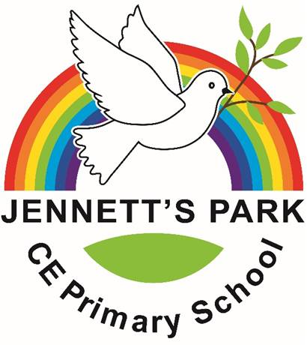
Governors Survey Summary – 2025
Thank you to all Parents who shared feedback. Here are the key highlights (latest 2025):

What Parents Are Most Positive About
- Happiness & Safety: 95% say children are happy and 95% say they feel safe at school.
- High Expectations - 82% feel the school keeps them informed about their child’s progress.
- Behaviour & Routines: 81% agree the school ensures pupils are well behaved / routines are clear.
- Curriculum Awareness: 92% know what children will learn during the year.
- Recommendation: 95% would recommend the school to another parent.
Participation (2025): 94 responses, representing 75 families.

Areas of Strength (Trends) Here are the key highlights from 2022 onwards:
- Sustained happiness & safety: Up from 90% → 95% (happy) and 86% → 95% (safe)
- Recommendation remains excellent: 95% (2025);
- SEND Support: 88% say pupils with SEND receive the support they need.
- Curriculum Awareness: 92% know what children will learn during the year.
- Communication & curriculum awareness improved:
  - Communication: 82% (2025)
  - Curriculum awareness: 92% (2025)
Areas for Continued Focus
- Behaviour & routines: 81% (2025). Action: restate expectations with parents/pupils; keep celebrating positives to rebuild momentum
- Communication consistency: Despite big gains since, keep driving clear, regular updates so all families experience the same high standard (82% in 2025).

What You Told Us You Value Most
- Strong leadership and clear vision.
- High standards and expectations for pupils.
- Commitment to continuous improvement and pupil wellbeing.

