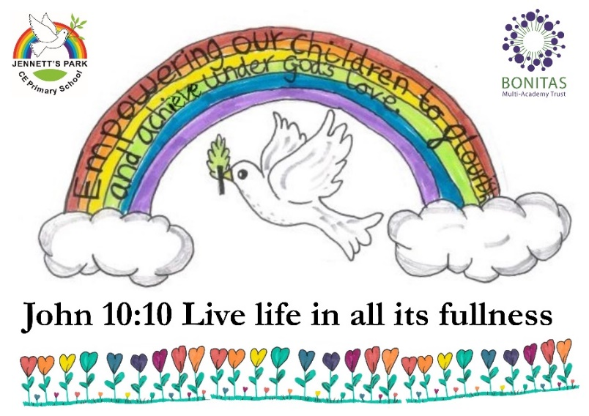

What RSE lessons look like at JP:

* Delivered by a teacher within the year group.
* Split into gender groups
* Question box (anonymous)
* Class rules agreed at the start of the topic by children
* Safe open space

***How does my child ask a question?***

Each class will have a question box, this will be only opened by the teacher and all children get opportunities to put questions into the box in the lesson and throughout the week. These questions will be answered in the following lesson.

***How in depth is the coverage?***

We follow the guidance from the government and cover the objectives listed under ‘Year Groups’ on the leaflet. We also use child friendly videos to help with explanations and reinforce correct terminology.

***How do you support my child?***

We ensure that the children understand the class rules and have a safe and open learning environment. The children know any questions are welcome and they receive breaks and reflection times after the lessons.

**Curriculum**

Jennett’s Park CE Primary School is a community woven together to flourish and achieve. As a church school we are guided by the Christian faith and values, however, we are an inclusive environment that enables all children and adults to engage in our curriculum. RSE is not dependent on religious affiliation but aims to embrace fundamental questions about the meaning and purposes of life and to learn about ourselves and one another.

These are some of the areas that contribute to our Relationships and Sex Education learning in school:

Puberty

Menstrual cycle

Conception

Babies

Sexual intercourse

**Delivery and Support**

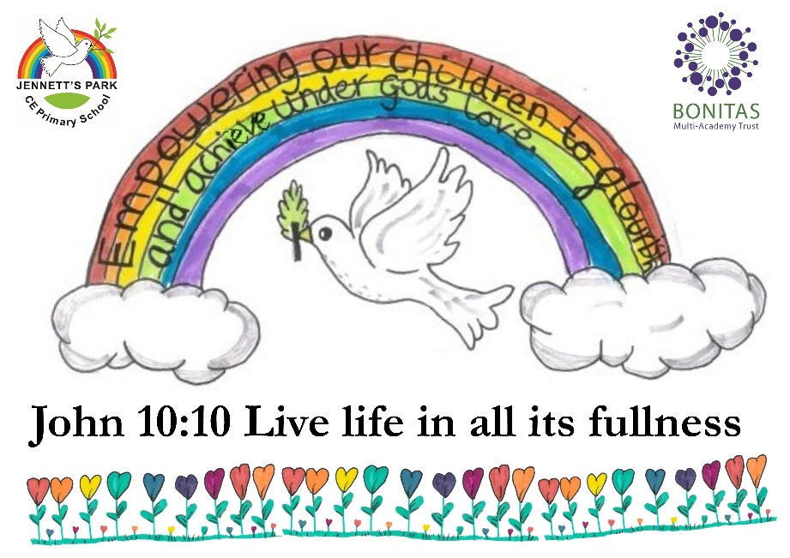

**Jennett’s Park**

**Relationships and Sex Education**

**Year Groups**



Part of our duty as a school is to provide a broad and balanced curriculum, and to promote pupil wellbeing. The school’s policy for Relationships and Sex Education (RSE) is based on statutory guidance from the Department for Education (DfE) (*Relationships Education, Relationships and Sex Education (RSE) and Health Education, 2019*), and we believe that by following this guidance as part of our wider curriculum, we will be able to provide children the opportunity and the freedom to ask questions and to explore the world around them.

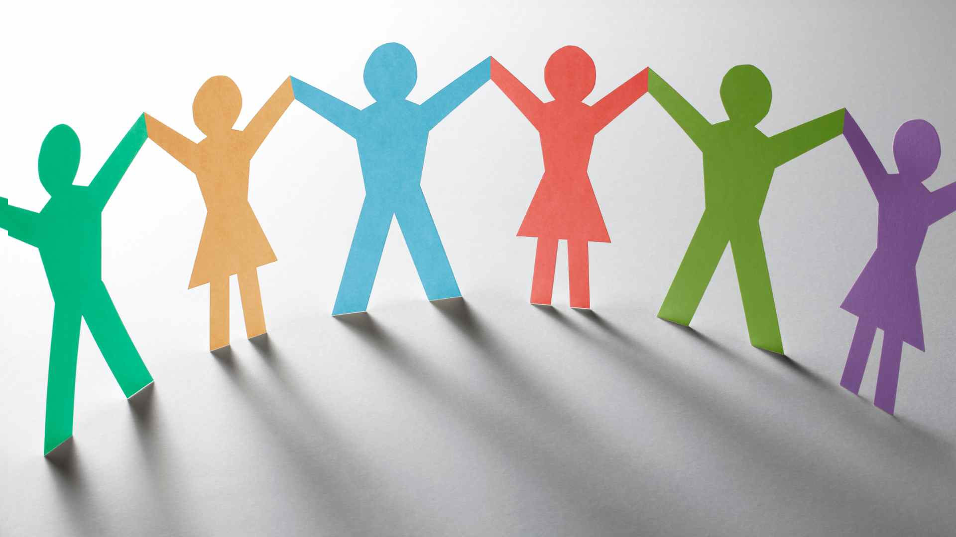

At Jennett’s Park CE Primary School, RSE is defined as learning about physical, moral and emotional development, love and care towards others, and about the teaching of relationships and sex (where age appropriate). Through the teaching of RSE children will learn about attitudes and values, personal and social skills and will develop their knowledge and understanding that will enable them to make informed decisions about their wellbeing. This also incorporates the learning about personal space and privacy.

In UKS2 the children will split off into gender groups for the delivery of RSE. Below are the learning objectives covered in each year group.

**Year 5**

* To understand physical changes during puberty.
* To understand the menstrual cycle.
* To understand emotional changes during puberty.

**Year 6**

* To understand the changes that happen during puberty.
* To understand the biology of conception.
* To understand the development of the baby during pregnancy.



In regard to Sex Education, we aim to teach within the Rainbow Values and the Christian understanding that sex is a normal part of life that God has given us. Whilst we use Sex Education to inform children about sexual issues, we do this in regard to matters of morality and individual responsibility and in an age-appropriate manner. Sensitivity and respect are shown to all children when teaching about personal relationships, and RSE is taught in a way that ensures there is no stigmatisation on children based on their home/personal circumstances.

At Jennett’s Park, we aim:

* To meet the requirements of RSE set by the DfE.
* To help and support children through physical, emotional and moral development.
* For the children to have the confidence and understanding to approach their relationships in a positive way.
* For children to have respect for their own bodies and for those of others.
* To enable children to move with confidence from childhood through adolescence to adulthood.
* To enable children to live confident and healthy lives.
* To help children understand how a baby is conceived and born.
* To ensure children are aware of personal space and their right to privacy.
* For the children to develop a respect for the views of other people.
* For the children to understand what they should do if they are worried about any aspect of sex or sexuality.

**Introduction**

**RSE Overview**