Name:___________ Class:_____ Date:__________

My Project
Is to design and make my own exciting costume that I might wear for a job I have when I grow up.

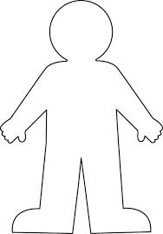

I chose to design a costume for….

