**Hollie Guard App**

This app allows you to keep an eye on your child while they are traveling using the Journey feature. Whenever they use this feature, their emergency contacts are informed when they have arrived at their destination.

With the free version, users can also use this app to get help quickly if they are in danger. If a user is in danger, they hold down the button for 5 seconds to raise an alert, which activates Hollie Guard and automatically sends their location to their designated contacts. Visit their website for further information: <https://hollieguard.com/>

**Emergency SOS calls**

You can set up emergency SOS calls on your iPhone/Android, so it calls the emergency services even when your phone is locked. Here’s how to set it up:

**iPhone**

At the same time, press and hold the side button and either volume button until the sliders appear. Once the countdown on Emergency SOS ends, release the buttons. You can also enable iPhone to start Emergency SOS when you press the side button five times.

**Android**

Press the power button five times or more. A five-second countdown begins before emergency services are called.

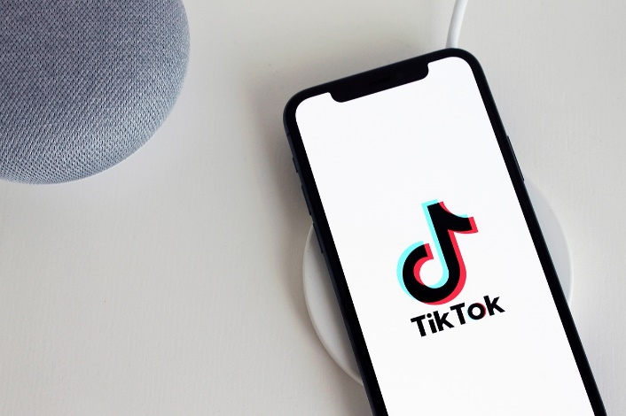**TikTok**

**You must be over 13 years of age to use TikTok.** Some of the videos on TikTok may not be appropriate for your child to view and there is also the risk of strangers contacting your child. If your child is using TikTok then make sure the appropriate security/privacy settings are on.

**Account set up**

By default, accounts for people under 16 are set to private at the start and we would recommend keeping it as this. This means your child can approve follower requests. You can read more about the other settings available (such as switching off comments and switching on restricted mode) here: <https://support.tiktok.com/en/account-and-privacy/account-privacy-settings>

**Inappropriate content, themes and challenges on TikTok**

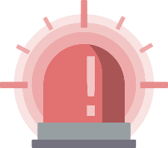Whilst against TikTok’s guidelines, explicit and inappropriate content can be found on this platform, for example nudity/sexual content and hate speech. We often see viral challenges on TikTok, some of which can be dangerous. If your child is using TikTok, chat to them regularly about what they are viewing and to ensure they know not to try challenges they see online.

**Family Pairing**

This allows you to link your own account to your child’s account. You can then set controls such as restricted mode (limit the appearance of content that may not be appropriate) and screen time management. You can find out more here: <https://www.tiktok.com/safety/en/guardians-guide/>

**Blocking and Reporting**

Ensure your child knows how to use the safety features available to them. You can find out more here: <https://support.tiktok.com/en/safety-hc/report-a-problem>

**Bullying on TikTok**

This article makes suggestions on appropriate settings as well as how to deal with bullying: <https://www.tiktok.com/safety/en-sg/bullying-prevention/>

**Tech Tips Live with Parent Zone**

You can watch back this 13-minute broadcast from Parent Zone (originally broadcast Jan 2023) which discusses what you need to know if your child is using TikTok. It’s an excellent overview including how algorithms work on social media. You can access it here: <https://parentzone.org.uk/tech-tips-live>

Users of this guide do so at their own discretion. No liability is entered into. Current as of the date released 1.3.23.

**Nintendo Switch setup**

If your child has a Nintendo Switch, have you set up the parental controls yet? You can either set parental controls up on the console itself or if you have a phone (or other smart device), Nintendo have created a free app that you can download and link to your console. We would recommend this app as you are able to monitor what your child is playing from your phone.

The app allows you to adjust various settings, including:

- Limit play time

- Restrict communication with others

- Restrict allowed games by age

You can find out more here:

<https://www.nintendo.co.uk/Support/Nintendo-Switch/How-to-Set-Up-or-Adjust-Nintendo-Switch-Parental-Controls-1494771.html>

**About Roblox**

PEGI rate Roblox with a Parental Guidance label (icon shown right), this is because of the huge level of user generated content within Roblox. It is rated for ‘Teens’ on Google Play and 12+ on the App store.

You can either use Roblox to create games or play games that other users have created. **As a lot of the content is user generated, it may mean not all games will be suitable for your child to view/play. It is important to set up Parental controls appropriate to your child.**

**What our jump scares?**

****Jump scares are often used in horror games on Roblox with the intention of scaring and frightening players, this could be through loud noises, frightening images or sudden movements. Some players may find jump scares frightening.

**What Parental Controls are available?**

Settings include:

**Hanni and the Magic Window**

Childnet have published a new book titled ‘Hanni and the Magic Window’. Aimed at children aged 3-7, the story is about speaking out and getting help if something goes wrong online. It is a terrific book to read at home with your child. Download a copy here:

<https://www.childnet.com/blog/take-an-adventure-through-online-safety-with-our-new-book-hanni-and-the-magic-window/>

- restricting chat

- setting spending limits and spending notifications

- enabling age-based experiences. If you enable Allowed Experiences, your child will only be able to join experiences that match or are below the age recommendations set. Age categories available are 9+, 13+ and all ages.

- view what your child is doing on Roblox, including recently played experiences, private message history and their friends.

You can find out more about the different settings available here:

<https://en.help.roblox.com/hc/en-us/sections/4410604750996-Account-Settings>

**Barclay’s Code Playground**

Help your child to develop their understanding of coding by taking part in the fun activities or video sessions on Barclay’s Code Playground:

<https://barclayscodeplayground.co.uk/parents-homepage-bdl/>

