12th January 2023
RE: Updating pupil records

Dear Parent/Guardian,

As part of our ongoing commitment to safeguarding children we are conducting a pupil information collection across the school. This census will ensure our information is accurate and we are able to contact the right people during an emergency. As part of best safeguarding best practise that we have two emergency contacts as a minimum, please do contact our Office if this is something you may find difficult.

Please complete and return the attached form as soon as you are able to.

Should your details require updating in future, such as a house move, new mobile number or allergy requirements please do let us know as soon as you are able. We anticipate this will be the last year distributing a paper copy, as we should be introducing Weduc soon. Weduc is a school app which will enable parents to update personal details, report absences and receive messages in one place. More details on the introduction of Weduc to follow soon.

As ever, if you have any questions, please do not hesitate to contact the Office. Or, please see our Data Protection policy which is available on our website: https://www.jennetts.bonitas.org.uk/headteachers-office/policies/

Yours sincerely

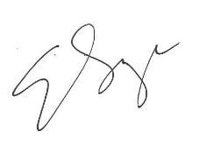

Elizabeth Savage
Headteacher

