Supporting Your Children Workshops
To book a space please email your name, school and contact number to
Inge.Taylor@bracknell-forest.gov.uk
Courses are for adults supporting children not the children themselves
Each course is a standalone 2-hour session
Please be aware that spaces are offered on a first come first served basis
Courses are delivered face to face, and you will be asked to complete an enrolment form prior to the start of the session – your space will then be confirmed.
Helping children to overcome anxious thoughts and worries
A 2-hour session looking at
- What happens when children become anxious
- The impact that current events have had on children’s mental health
- Techniques for helping children deal with their fears / worries
Anxiety 5  5 spaces | Wednesday 19th October 2022  @ Bracknell Open Learning Centre |  | 9.30 – 11.30 am
Anxiety 3  7 spaces | Wednesday 2nd November 2022  @ Bracknell Open Learning Centre |  | 6.30 – 8.30 pm
Anxiety 4  14 spaces | Monday 21st November 2022  @ Bracknell Open Learning Centre |  | 9.30 – 11.30 am
Managing Behaviour in a Positive Way  A 2-hour session looking at  - Gain insight into your own parenting style / relationship with your child  - Learn or revisit positive ways of managing behaviour  - Strategies to deal with unacceptable behaviours |  |  | 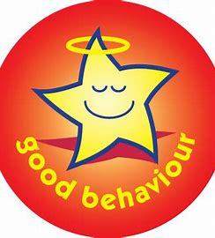
MB20  2 spaces | Friday 14th October 2022  @ Bracknell Open Learning Centre |  | 9.30 – 11.30 am
MB 22  6 spaces | Thursday 3rd November 2022  @ Bracknell Open Learning Centre |  | 6.30 – 8.30 pm
MB23  19 spaces | Monday 14th November 2022  @ Bracknell Open Learning Centre |  | 9.30 – 11.30 am
Parenting pre / early-teens in a Positive Way (aged 10 – 13)  (New course)  A 2-hour session looking at  - Gain insight into the impact of your parenting style (positive & negative)  - Positive techniques for managing older children’s behaviour  - Boosting your relationship and communication with your child |  |  | 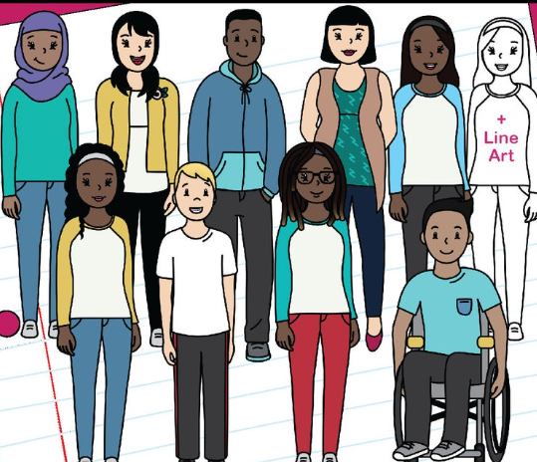
 | Contact me to add name to the waiting list for future sessions
Reducing Sibling Rivalry
A 2-hour session looking at
- Encouraging a more harmonious sibling relationship
- Learn / revisit techniques for children to cope with being a sibling
- Boosting children's emotional literacy
 | Contact me to add name to the waiting list for future sessions
Single Parent, Separated and Blended families – supporting children to cope with different family dynamics (New course)
A 2-hour session looking at
- Different family dynamics and how they can work
- Parental conflict resolutions
- Being the best parent that you can be for your child
 | Contact me to add name to the waiting list for future sessions
Supporting Children to get a Healthy Night’s Sleep  A 2-hour session looking at  - The different sleep issues facing our families  - Tips on how to get a good night’s sleep.  - Help children develop good sleeping habits |  | 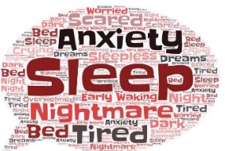
Sleep 11  10 spaces | Monday 17th October 2022  @ Bracknell Open Learning Centre |  | 9.30 - 11.30 am
Sleep 12  10 spaces | Thursday 17th November 2022  @ Bracknell Open Learning Centre |  | 6.30 – 8.30 pm
 | Contact me to add name to the waiting list for future sessions
Supporting a smooth transition to secondary school (YR 5/6 parents)  A 1 ½ hour session looking at  - What the transition involves  - The positives and concerns of transitioning to a new setting  - Boosting your child’s ability to have a smooth transition |  |  | 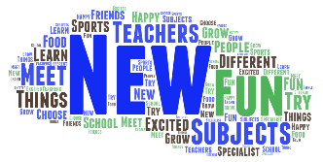
 | Contact me to add name to the waiting list for future sessions

