**Participation in ECO Rewards scheme**

17.10.22

Dear Parents and Carers,

We are pleased to announce an exciting new initiative that we can offer to Jennett's Park CE Primary School families in partnership with Bracknell Forest Council and Ecological Rewards Ltd.  We are delighted to partner in the Eco Reward Scheme to encourage walking and cycling rather than driving.  We will be joining Warfield CE Primary, St Joseph’s Primary, St Michael’s CofE Primary, Harmans Water Primary, Ascot Heath Primary, Crown Wood Primary, King’s Academy, Easthampstead Park Community School, Ranelagh, Edgbarrow and Garth Hill College.

Eco Rewards is a way for the user to report green journeys around our school and Bracknell town using a smart tag and dedicated blue ‘reader devices’ that are situated around the Bracknell area. They will be located on 3 walking routes to the school.  Exact locations can be viewed at: [www.ecorewards.co.uk/bracknell/eco-rewards-locations](http://www.ecorewards.co.uk/bracknell/eco-rewards-locations)

By using your tags to record your green journeys, pupils can enter prize draws and receive awards from the scheme whilst watching their carbon savings grow. In addition to the personal benefits and environmental impact, children who participate can collect points for their year groups.  As a school we will be able to track the carbon savings we have made as a community so the children will be able to measure their impact and track their progress.

We have 300 tags and will be giving them to children on a first come first served basis. Please come to the office to collect your tag. Family members can also join in by using their BFC e+ cards or by registering via our new app to get assigned a unique ID and scanning QR codes to participate.

We look forward to seeing our first reports

Kind Regards,

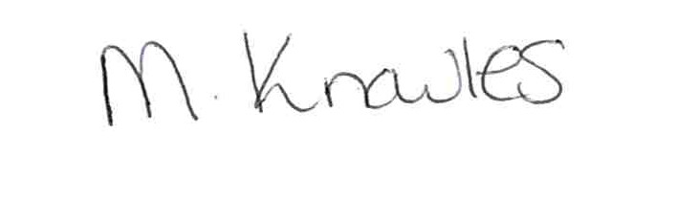

Megan Knowles

PE Subject Lead