Reading Prompt Questions
You may like to ask your children these questions, when you are reading with them.
Remember to ask a variety of questions, and to use the text to help you explain your answers:
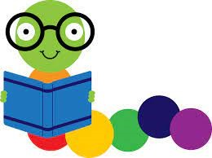
I know this because in the text it says….

Fiction:
- Who are the main characters in the story?
- Which character do you like most and why?
- Where is the story set? How do you know?
- How did the story make you feel and why?
- How does the main character feel during the book?
- What would the main character be likely to do if s/he visited our school?
- Did you like the way the story ended? Why or why not?
- Which character in the book would you choose for a friend? Why?
- Do you have any unanswered questions about the story?
- What happened in the story? Put the events in order.
- What do you think happened after the story finished? Why?
- If you could add any character to the story, from any story, who would you add and why?
- Does this story, or the characters sound like anything you have read before?

Non-fiction:
- Which facts did you find interesting? List your top 5 and explain what made them interesting for you.
- Describe the most interesting thing you learned from the book.
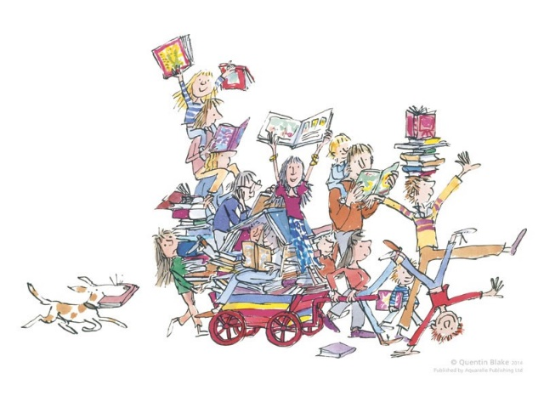
- What is the most important thing the author wanted you to learn or think about after reading the book? Why?

Any genre:
- Write a summary of what you read in your book today.
- Write down 5 adjectives that are in the book.
- Would you recommend this book to your friend? Why?
- Describe anything or anyone you would like to know more about after reading the book. What about this person/event made you want to know more you? What more would you like to know?
- What type of book did you read? How do you know it is that type?

