Jennett’s Park CE Primary

Curriculum Policy

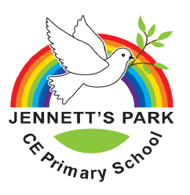

Date reviewed | March 2022
Date of Next review | March 2025
Published
Website Status | Yes

Contents
1. Aims 3
2. Rationale 3
Rainbow Promise 4
Owl Learning Behaviours 4
3. High Expectations 5
4. Legislation and guidance 6
5. Organisation and planning 6
Raising Standards 6
6. EYFS 7
7. Planning 7
Long Term 8
Termly Overview Planner 8
Daily teaching tools 8
Planning Non-negotiables 8
9. Learning Weeks 9
10. Children’s’ Leadership 9
11. Inclusion 9
12. Monitoring arrangements for Impact (Appendix 5) 10
13. Links with other policies 10
Appendix 1 Long term planner 11
Appendix 2 Termly Overview planner 11
Appendix 5 Subject Leader Impact Documents 12
13

1. Aims
‘The national curriculum 2014 provides pupils with an introduction to the essential knowledge that they need to be educated citizens. It introduces pupils to the best that has been thought and said; and helps engender an appreciation of human creativity and achievement. The national curriculum is just one element in the education of every child. There is time and space in the school day and in each week, term and year to range beyond the national curriculum specifications. The national curriculum provides an outline of core knowledge around which teachers can develop exciting and stimulating lessons to promote the development of pupils’ knowledge, understanding and skills as part of the wider school curriculum.’ National Curriculum 2014
The aims of our curriculum here at Jennett’s Park CE Primary are to ensure we live out our vision:

Empowering our children to flourish and achieve under God’s love

2. Rationale

The purpose of this curriculum policy is to state clearly the factors that we feel are important in influencing the effective route to learning of the pupils in our care, to create a shared ethos among the staff and to give a consistency of approach across the school. It pervades every aspect of school life. We ask ourselves often ‘What do our children need to do in order to be successful citizens and global contributors?’
Our aims here at Jennett’s Park are to ensure we live out our vision: Empowering our children to flourish and achieve under God’s love. This comes from the passage in the bible where Jesus says: I have come to let you live life in all its fullness (John 10:10).
Our Rainbow Promise underpins everything we do at school. Just as the Rainbow was a sign of God’s promise to Noah that from that moment God would enable Noah and the people of the earth to flourish and experience life in all its fullness. So as a school community we promise to do our best to enable all the pupils and adults of our school to flourish academically and professionally so that they might reach their potential.

The Rainbow is also a symbol of the diversity of our school community, but as a church school we recognise that we are all created and valued by God, and so as a school community we commit to care for and value each other.

The dove symbolises our need to persevere in some aspects of life as it is not always the first time we find success. It was not the first time that Noah had tried to find dry land and so we much seek strength within ourselves and from God to achieve.

All children and young people have a right to a primary education, which should be free. Our aim is that learning at Jennett’s Park CE Primary School should empower children. It should celebrate success and progress for all, and be part of our role as heart of the local community.
These are our Promises to keep to our children to be able to serve the common good with our work as part of the Church of England. By following our Promises we know our curriculum suits local needs
At Jennett’s Park we are: | Our Promises:
Educating for Wisdom, Knowledge and Skills | To help grow resourceful, resilient and reflective children who are equipped with the skills, knowledge and tenacity empower themselves, their learning throughout their lives.
Educating for Hope and Aspiration | To inspire and enrich lives beyond current opportunities and experiences in order to open minds to the potential their future holds
Educating for Community and Living Well Together | To be a multi-cultural, inclusive community of individuals loved by God who feel valued and involved where we create qualities of character to enable people to flourish.
Educating for Dignity and Respect | That children might know how much that they are loved and valued by so that they might show dignity and respect for themselves and others by carefully and safely thinking through their actions.

Rainbow Promise
This is at the heart of what we do. Our values are central to us achieving and being well.
These are our Values we try to live each day
Love
Honesty
Respect
Peace
Forgiveness
Patience
Support
Kindness & Joy
Our adapted PSHEC and Circle time curriculum covers the following,
- Sex and relationship education
- Spiritual, moral, social and cultural development
- British values

Owl Learning Behaviours
Each week children are chosen for showing Owl learning behaviours or following our Rainbow Promise. As a school, we have developed a set of values which reflect what we believe to be key attributes to being a successful learner. We encourage children to take responsibility for their own learning, to be involved as far as possible in reviewing the way they learn and to reflect on how they learn.
C - Collaboration
O - Optimism
P - Perseverance
P - Pride
I - Independence
C - Challenge
MD - Managing Distractions

3. High Expectations
Our expectations are very high because our learners deserve the very best. High expectations are flattering; they tell our students that we fully believe they have what it takes to achieve the things we want them to achieve. Low expectations convey the opposite: that they can’t achieve, can’t behave, and can’t get along with each other. High or low, achievement and behaviour moves in the direction of the expectation.
We set three types of high teacher expectations: academic (attainment and progress), behavioural (learning behaviours and conduct) and social (how the students interact with staff and each other). We are trained to give our children the best and to provide learning opportunities and experiences that maximise learners’ progress.
We have designed a fully comprehensive curriculum framework that meets the requirements of the latest National curriculum review. Our children's learning is both meaningful and benefits from a specific focus on the core requirements of the English and Mathematics curriculum.

Our curriculum continues to ensure that:

- We provide a broad and balanced education for all pupils
- We enable pupils to develop knowledge, understand concepts and acquire skills, and be able to choose and apply these in relevant situations
- We support children in developing both global and international perspective and the fundamental British Values.
- We support pupils’ spiritual, moral, social and cultural development through following our Rainbow Promise
- We support pupils’ physical development and responsibility for their own health, and enable them to be active
- We promote a positive attitude towards learning through our Owl Learning Behaviours
- We ensure equal access to learning, with high expectations for every pupil and appropriate levels of challenge and support
- We promote the learning and development of our children and ensure they are ready for life

4. Legislation and guidance
This policy reflects the requirements for academies to provide a broad and balanced curriculum as per the Academies Act 2010.

It also reflects requirements for inclusion and equality as set out in the Special Educational Needs and Disability Code of Practice 2014 and Equality Act 2010, and refers to curriculum-related expectations of governing boards set out in the Department for Education’s Governance Handbook.

It complies with our funding agreement and articles of association.

In addition, this policy acknowledges the requirements for promoting the learning and development of children set out in the Early Years Foundation Stage (EYFS) statutory framework.

5. Organisation and planning
How our curriculum is organised and delivered at Jennett’s Park CE school:
Every child at Jennett’s Park CE Primary deserves to be challenged, stimulated and feel success within their learning. They are entitled to have feedback to as to how they are progressing within their learning and a chance to self-reflect as to how they think they are doing. They need to be provided with activities that teach them the core skills and values they will need as life- long learners and the eagerness to tackle new problems.

Skills, attitudes and values are developed to prepare the children for the next stage of learning and enable them to be successful in the community. We believe that effective learning takes place when there is considerable emphasis on active involvement, opportunities to talk both imaginatively, expressively and to explain and clarify thinking.

Our creative curriculum supports our four promises to serve the common good. We make connections across subjects and in our schema where possible and meaningful. Our pupils are offered a very wide range of experiences to extend their understanding of themselves and the world in which they live.

We actively promote British values of democracy, the rule of law, individual liberty, and mutual respect and tolerance of those with different faiths and beliefs to prepare our pupils for life in modern day Britain.
Our curriculum ensures all statutory guidance relating to the Early Years Foundation Stage and the National Curriculum is fully implemented.

Raising Standards
Learning is the purpose of the whole school and is a shared commitment, striving relentlessly for the best outcomes and impact. Continued and sustained improvement is dependent upon improving the quality of teaching and learning that is taking place on a daily basis, therefore, any attempt to raise standards in our school must be focused on the classroom. Our curriculum is planned to help develop learning links.

Learning is those changes in long term memory so you act, do and think differently.

We all learn by connecting new ideas or concepts to what we already know. This is as true for children as it is for adults. We can make accurate connections, or we can misunderstand something and labour under a misconception, connecting information to the wrong part of our mental map, or schema.

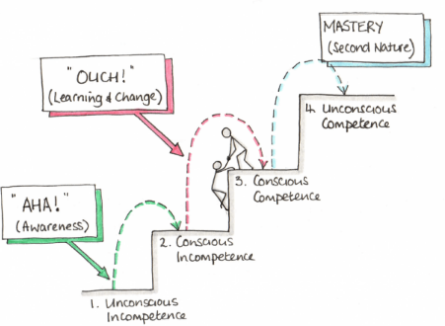
If we are missing too many parts of the puzzle or too many steps in the chain, then making the right mental connection can simply be too much of a leap for us, and we find ourselves unable to learn the new concept. We sometimes call the effect of those multiple gaps in the chain cognitive overload. We aim to close this with our interventions (see inclusion below).

Since this is how our minds work, we think about what we teach with real clarity. What end points do we wish children and young people to reach: what do we want them to know and be able to do? We have laid these out in our promises. We want all children to move from conscious incompetence to unconscious competence!

We think about what are the key concepts that will enable pupils to get to those endpoints. And to help them make the right connections, we think about the order in which those concepts are taught.

6. EYFS
In Reception and Nursery, we follow the Early Years Statutory Framework for the Early Years Foundation Stage, published in March 2021 by the DfE. This Framework specifies the requirement for learning and development in the Early Years and provides specific areas of learning we must cover in our curriculum. These areas are:
- Personal, Social and Emotional Development
- Physical Development
- Communication and Language development
- Literacy
- Mathematics
- Understanding the World
- Expressive Arts and Design

For more details please read the EYFS policy

7. Planning
Progression: With each year group in a team following the same theme, it is important to ensure that progression takes place. Subject Leaders ensure that there is progress in disciplinary and substantive knowledge through the year groups.
Substantive knowledge is the specific, factual content for the subjects, which must be connected into a careful sequence.
Disciplinary knowledge is best described as the action taken within a particular subject to gain knowledge i.e. how we gain substantive knowledge.

Long Term Planning consists of a grid to layout an overview of the year. (Appendix 1)
The grid has been developed from subject leader progression maps and considers National Curriculum objectives. It reflects school vision, targets and personalised aims for the community. This planning is essential as it ensures that progression is taking place across the school within the whole school theme.
Termly Overview Planner (Appendix 2) is the planning which is completed by the class teachers to show the lessons within a unit or theme. It clarifies learning objectives across the term within each subject taught. The learning objectives on these plans will be taken directly from the long-term plan or reflect a need identified by the class teacher’s assessment for learning.
These should:

→ Be cross curricular relating to the connector where possible
→ Include experiences to engage and motivate the children
→ Include key learning objectives
- Consider the sequence of learning across the topic
→ Include key knowledge, skills and link to our 4 promises
→ Lead up to the challenge and/or celebration
- Consider prior learning and long-term memory

Daily teaching tools will identify clear steps to Success to help children achieve the Learning Intention, Higher order questioning to extend children’s thinking, as well as differentiation and the role of other adults.
The whole curriculum is enhanced through an exciting and diverse range of trips.
See our EYFS policy for information on how our early year’s curriculum is delivered.

Planning Non-negotiables

Planning should be focussed on the learning taking place. There may be comments made about activities that are being set but these should reference the knowledge, skills and understanding that should be taught and learned. Planning should be succinct but be understandable by others.
The following expectations are in place for all KS1 and KS2 classes. This will be monitored during planning scrutinies.

Literacy
*Long term Literacy plan for whole year, showing units covered and the lengths approximately taken.
*Literacy unit plan for each unit taught.
*Literacy weekly plan following generic proformas.

Maths
*Long term Maths plan for whole year, showing units covered and when, with a counting focus and maths mission per half term.
*Maths weekly planning following generic proformas.

Foundation subjects
*Long term curriculum map for whole year, per year group.
*Tick sheets with new curriculum objectives on showing coverage of year group/key stage objectives.
*Termly Overview Planner
*Notebook files where required which make clear learning objectives, success criteria and key questioning.
*RE/PE other schemes followed can be photocopied and evaluated/annotated when taught.

9. Learning Weeks
Each year we hold a range of themed curriculum weeks and learning days. The following were held in 2018-19:
- Black History Moth
- Reading Month
- Friendship Week
- Arts Week
- International Week - including the International Tea for families
- Esafety Day
- World Book Day
- Charity Week ( Christmas and Lent)

10. Children’s’ Leadership
At Jennett’s Park CE Primary, we believe that all children should have the opportunity to develop their leadership potential. There are many informal opportunities given to children to do this during their time at school. We provide many formal opportunities to develop leadership as well. Children do this through the:
- Children’s' School Council Team
- Digital Leaders Team
- Prefect System
- Playground Buddies

11. Inclusion
Teachers set high expectations for all pupils. They will use appropriate assessment to set ambitious targets and plan challenging work for all groups, including:
- More Able and Gifted and Talented pupils
- Pupils with low prior attainment
- Pupils from disadvantaged backgrounds
- Pupils with SEN
- Pupils with English as an additional language (EAL) or Advanced Bi Lingual ( ABL)
Teachers will plan lessons so that pupils with SEN and/or disabilities can study every National Curriculum subject, wherever possible, and ensure that there are no barriers to every pupil achieving.
Teachers will also take account of the needs of pupils whose first language is not English. Lessons will be planned so that teaching opportunities help pupils to develop their English, and to support pupils to take part in all subjects.

Further information can be found in our statement of equality information and objectives, and in our SEN policy and information report.

12. Monitoring arrangements for Impact (Appendix 5)
Governors monitor whether the school is complying with its funding agreement and teaching a “broad and balanced curriculum” which includes the required subjects, through:
- School External Visits reviews
- School Internal Visitors reviews
- Mid-year
- Governor Visit Days
- School Council meetings
- Staff, parent and Child questionnaires

Subject leaders/curriculum leaders monitor the way their subject is taught throughout the school by holding conversations with children, parents and staff but may use methods such as planning scrutinies, learning walks book scrutinies, observation of teaching and learning, team / joint teaching and mini audits (e.g. of standards of work on display/ knowledge of teachers in ... ) to ensure quality control.
Subject leaders/curriculum leaders also have responsibility for monitoring the way in which resources are stored and managed.

13. Links with other policies
This policy links to the following policies and procedures:
- EYFS policy
- Teaching & Learning Policy
- Assessment policy
- SEND policy
- Equality Policy

Appendix 1 Long term planner

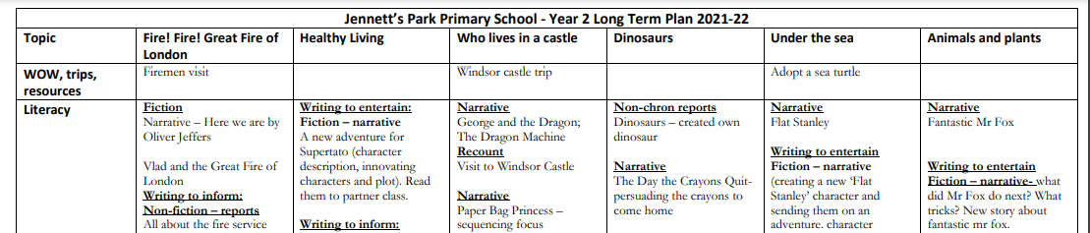

Appendix 2 Termly Overview planner
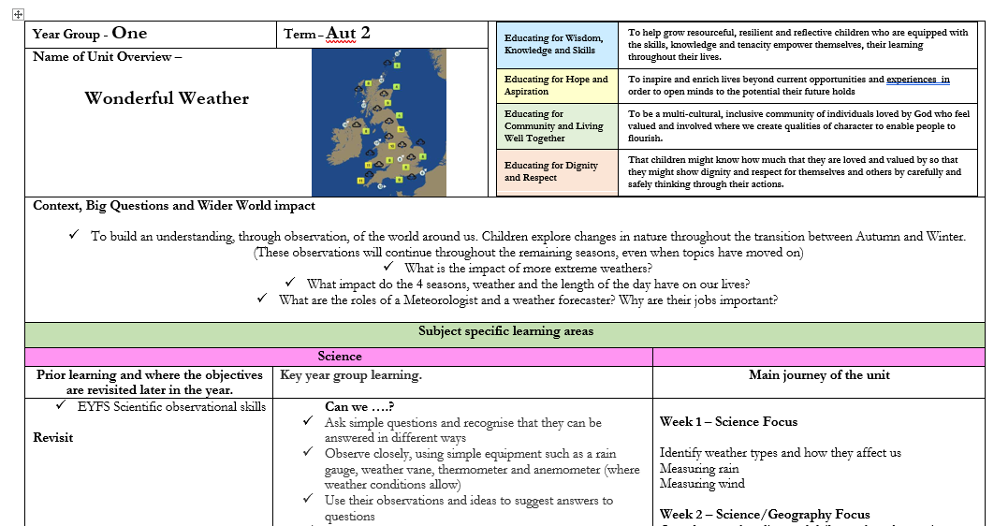

Appendix 5 Subject Leader Impact Documents
