PTA pumpkin growing competition!
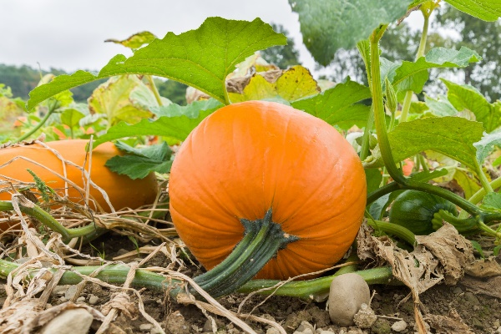
The PTA have set the school a challenge to get growing our own pumpkins!
You will plant your pumpkin seeds in class and then take them home to care for them and grow them over the Summer. There will be prizes for the most successful!
The prize categories are
- Biggest pumpkin
- Smallest pumpkin
- Heaviest pumpkin
- Best looking pumpkin
- Funniest looking pumpkin!

Harvest and judging will take place October 22nd 2022

How to grow your pumpkin
- Sow Edge Downwards 1.5cm deep in compost provided.
- Water well and place in light warm position.
- Once the plant has grown a little, plant it outside with plenty of space to grow
- Keep Moist do not over water.

For more information https://www.rhs.org.uk/advice/grow-your-own/vegetables/pumpkin
Donated by Luke Thorn
Fine Line Gardening Services

