19th October 2020
RE draft Relationships and Sex Education (RSE) policy
Dear Parents/Carers,
Attached to this letter is our draft Relationships and Sex Education (RSE) policy. We have a well developed policy which has been in existence for the past few years which was initially developed by parents. All primary schools are now required to adopt the Relationships aspect of RSE following the statutory guidance set by the Department for Education by summer 2021. We thought we would update a few sections to reflect our Rainbow Values and the work we do in schools. As a school, Jennett’s Park has decided to also include Sex Education within our wider Personal, Social, Health and Economic Education (PSHE).
Now more than ever, PSHE is a vital part of our pupils’ education, as it provides them with opportunities to develop the knowledge and skills they require to thrive as individuals and to manage their lives, both now and in the future.
Please read through our RSE policy and if you have any comments or questions, email these in to secretary@jennettspark.bracknell-forest.sch.uk. This will be the first item of discussion at our Parents Council Meetings—If you would like to join all are welcome 9th November 1:30 via zoom. Again email secretary@ for joining details

Yours sincerely

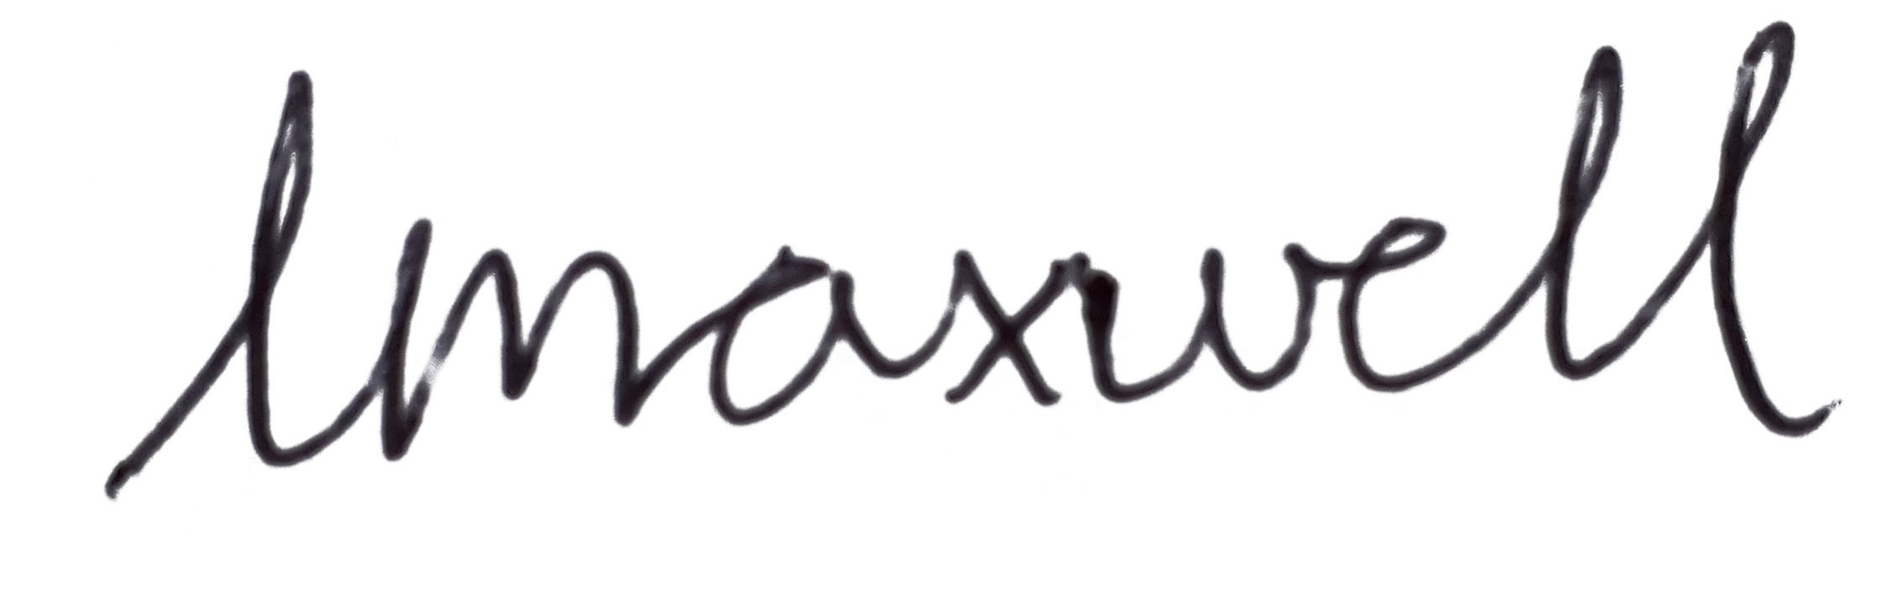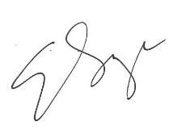

Elizabeth Savage Miss L Maxwell
Headteacher PSHE subject leader

