Age 5-11

Uncle Raj has three children. Next year, when they've had their birthdays, Naomi will be 5, Alex will be 6 and Chris will be 7. The family has decided on something rather unusual for part of their presents.  
  
All three children have their birthday in the late spring and since they are keen on gardening they are going to buy some plants for the garden, one for each year they have been alive.  
  
Here is the plan of their house and garden:

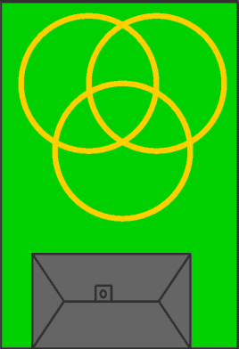

You notice that there are three circular paths that cross over each other. Each child is to have a circle but there will be some bits that are shared, around the middle.

When the time comes, the four of them go off to the garden centre to choose the plants. They do not have a lot of money so they're looking for special offers. They find a very special offer which gives a good discount if you buy ten plants altogether. The three children say that that is no good because they need more than ten. But Uncle Raj realises they can manage with only ten.

They go to the cafe and have some cool drinks, and Uncle Raj draws a plan of the three paths and puts little marks to show the plants.

Here is his idea:

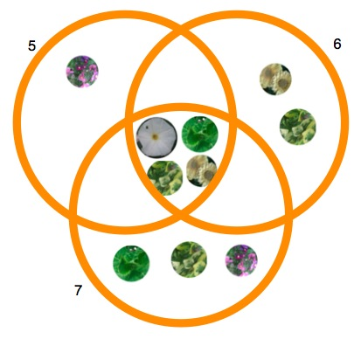

The children are fascinated to see that Naomi has 1 and shares 4, Alex has 2 and shares 4 and Chris has 3 and shares 4. They think that's rather cool and it saves them a lot of money. So they finish their drinks and off they go to buy their ten plants.

Well now it's your turn to have a go and find some different solutions.  
REMEMBER:- You must use exactly ten plants (no more, no less)  
REMEMBER:- The circles must contain 5, 6 and 7 plants (no more, no less).

As you try, you may find that you are developing a system for getting the next one. If so, we'd love to hear about it.  You might like to try to find them all, and write about all the things you notice about each solution.

You could print off [this sheet](https://nrich.maths.org/content/98/02/bbprob1/Plants%20Recording.pdf) to help you record them, if you like. However, you might find a different way of recording them altogether. Some people find it's easiest to do it quite large and have ten objects to move around in different places.

As with most of these challenges you can and should ask "I wonder what would happen if ...?" Well you might try a different number of objects (plants). You could try different numbers for each circle, as if the children were different ages.

# Butterfly Flowers

##### Age 5 to 7

Look at these butterflies and flowers.  All of them have a number.

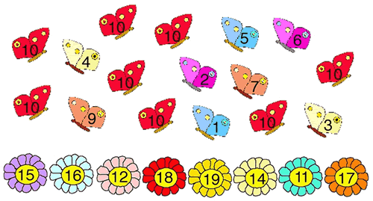

Can you find two butterflies to go on each flower so that the butterfly numbers add to the flower number?  
  
Which pair of butterflies has no flower to go to?  Why?  
  
Which flower cannot have a pair of butterflies on it?  Why?  
  
  
These are how three children started this task:

**Zac said:**

I noticed there were eight butterflies which all had the number 10 on them, so I put one on each flower.

**Mona said:**

I picked two butterflies and added their numbers together.

**Anita said:**

I noticed that if I added two red butterflies together I didn't get a flower total.

Did you start the problem in the same way as any of these children?  
What do you think about each method?

# The Amazing Splitting Plant

##### Age 5 to 7

The splitting plant grows in a special way.

In the first week, the stem splits into two branches.  
In the second week, each of these two branches split into another two branches - making four branches altogether.  
  
This keeps happening every week, until at the end of the sixth week each branch grows a flower.  
  
How many flowers will the plant have?

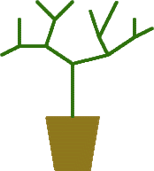

# Seven Pots of Plants

##### Age 7 to 11

There are seven pots of plants in a greenhouse. They have lost their labels.

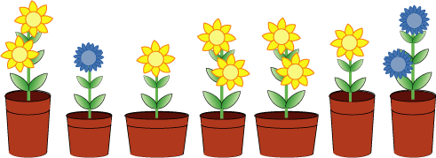

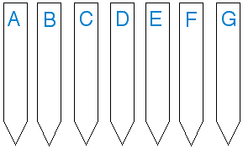Perhaps you can help re-label them.

F and G have wide pots.  
C, E and F have just one flower.  
B and D have tall pots.  
B and E have blue flowers.

Can you do it?