Being Green

Literacy:
- Create a poster to show others how to Reduce, Reuse and Recycle https://www.youtube.com/watch?v=OasbYWF4_S8 will give you lots of tips!

- Write an advert to persuade people to save water! Use https://www.youtube.com/watch?v=rl0YiZjTqpw for guidance on how to save water.

- Write a persuasive letter to a supermarket to encourage them to reduce their plastic packaging. Remember to include good reasons and arguments backed up with facts to explain why you think they should do this.


- Write a set of instructions for one of the art and craft activities or you could write up one of the science experiments!

- Watch https://www.literacyshed.com/girlwithyellowbag.html
Re-write the story with you and your yellow bag.
What rubbish would you put in your yellow bag and recycle?
What beautiful things would the rubbish make?

- Watch ‘Treasure’ https://www.literacyshed.com/the-thinking-shed.html. You could describe the old lady's day, as a 1st person diary entry or as a story. Could she write a letter to a friend, showing what she has found?

Art and craft ideas
See what you can make out of recycling! 75 recycled art and craft activities for children
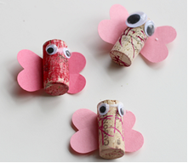
https://www.notimeforflashcards.com/2014/04/recycled-art-project-for-kids-2.html
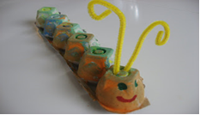

Or visit http://treetoolsforschools.org.uk/activitymenu/?cat=helping for lots of fantastic ideas for creating crafts for the garden using recycled or natural materials.
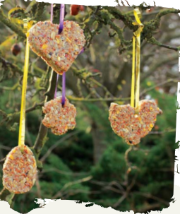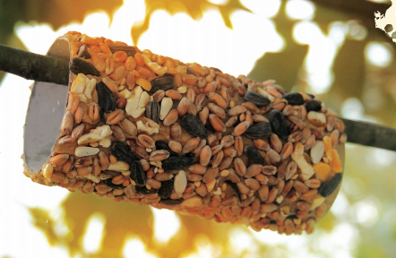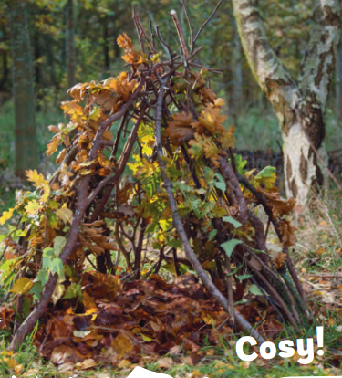

Make your own butterfly feeder using recycled plastic you have at home:
https://www.youtube.com/watch?v=5gAPoeH_rxQ
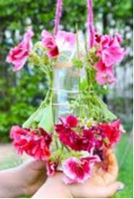
https://www.youtube.com/watch?v=t9kC1l0F1ik

I wonder how many butterflies
you will see? You could keep a
tally of the different breeds/
colours, or even draw them!

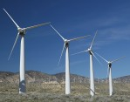
You could have a go at making your own compost, to help the flowers in your garden grow! https://www.gardeningknowhow.com/special/children/composting-ideas-for-kids.htm

Science
There are lots of fun, green activities linked to Earth Day at https://learning-center.homesciencetools.com/article/earth-day-activities-for-kids/

Environmental science projects for children https://www.kiwico.com/diy/explore/environmental-science-projects

Make your own terrarium:
If you didn’t make one before, in plants and flowers week, now would be a great time to make a terrarium (a mini-eco system), to explore what helps plants to grow and what inhibits their growth. Here is another way to do this:

Equipment needed:
- 2 litre plastic drink bottles in varying colours
- Cress or other seeds which grow quickly
- Petri dishes
- Cotton wool
- Sellotape

Constructing your terrarium:
- Put some cotton wool on small, side plate- you may wish to measure this accurately.
- Count out a specified number of seeds, eg. 20.
- Add a specified amount of water - around 20ml works well.
- Cut the bottle to a specified height or volume - you can use both the top and the bottom ends.
- Put the bottle on top of the side plate dish, as in these photos, and seal the bottle around the dish with sellotape to make a self-contained eco-system.
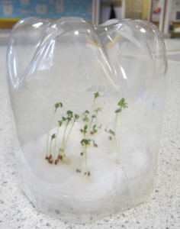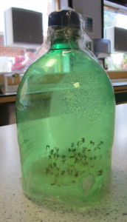

Running the experiment
You will need to decide what data you want to collect before you start the experiment. You will also need to decide whether to collect data weekly or just after a certain number of weeks. The number of weeks depends on what seeds you use - cress should show significant growth after two or three weeks.
Here are some suggestions, but you may have other ideas:
- the number of seedlings which germinate successfully (what criterion will you use to decide when a seedling has successfully germinated?)
- the height of the seedlings - either individual seedlings or the average per terrarium
- the surface area of cotton wool covered - if you decide to focus on this you will need to think carefully about how and where you sow your seedlings on the cotton wool
- the colour of the plants

Music
Try creating your own song, or rap to encourage others to reduce, reuse and recycle
https://www.youtube.com/watch?v=qtyBzFV9yTs KS2
https://www.youtube.com/watch?v=heskCH-YADQ KS1
Michel Jackson video- Earth Song https://www.youtube.com/watch?v=XAi3VTSdTxU

Maths
KS2:
https://www.bbc.co.uk/teach/class-clips-video/maths-ks2-calculating-food-waste-and-the-environmental-cost/z44qpg8
This clip could be used to conduct a survey to find out the percentage of food that is wasted in your house.
- Use the ideas from Newton Ferrers to think of ways of collecting your own data at home, how much food do you waste? Could you compare your data with someone else’s?
- How would you change or extend your survey?
- How could you use the survey and present the results to encourage children to reduce food waste?
- How long do you need to continue a survey to feel confident that the results are reliable?

KS2:
Using maths to recycle rubbish https://www.bbc.co.uk/teach/class-clips-video/maths-ks2-using-maths-to-recycle-rubbish/zk97nrd
Try to come up with as many different possible uses for recycled plastic bottles as possible. How many have you got? Which are the most useful or creative?

Maths sorting activity:
Collect some rubbish and find different ways of sorting it- e.g. Can it be recycled, can it be reused, or does it need to be thrown away? To show these results, you could create a:
- Graph
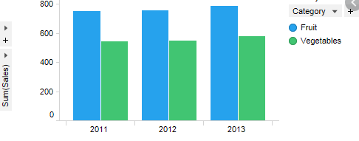

- Pictogram
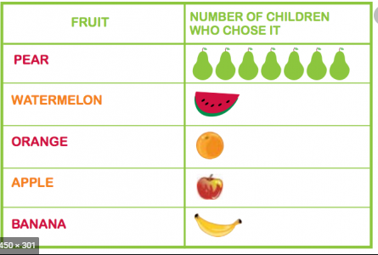
- Or even use sorting circles to make a Venn diagram.
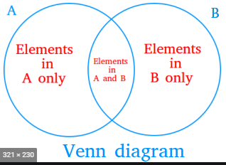

Counting - Keep a diary over the week of how many items of single use plastic you use in your household. Can you think of any ways to reduce this?

Weighing- Make an estimate of how much 1 day or 1 week’s rubbish in you how is- then measure and record the actual weight.

Problem solving- if I use 3 tins, 4 cartoons 3 plastic wrappings and 1 milk bottle each day- How many items will I have in my rubbish at the end of a week? A month? A year?

DT/ Cooking
Why not try one of these healthy and sustainable recipes from the WWF https://www.wwf.org.uk/recipes


Make your own recycled invention! What could you invent, that would improve recycling in your home? Could you also make this invention out of recycled/ resuable materials?

DT challenge: Pick one of these objects and see if you can think of 5 alternative things you can make or do with these objects. Your siblings can play too! Who has the most useful ideas?
