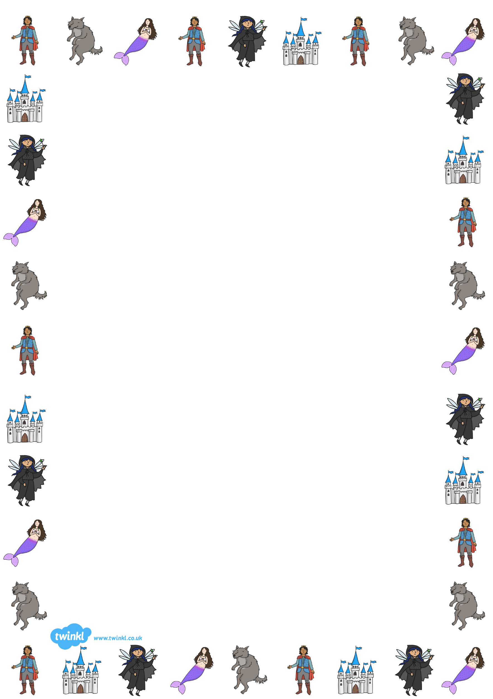
Fairy Tales
Literacy
Listen to fairy tales either from books at home or on: https://www.storynory.com/archives/fairy-tales/
Writing Activities
- Write a ‘mixed up’ fairy tale using characters and ideas from different fairy tales.
- Imagine that you meet your own fairy godmother - what would happen?
- Choose a 'bad' character from a fairy tale, such as the Big Bad Wolf or The Ugly Sisters and write a letter to them to try to persuade them to change their ways - remember, you'll need to explain why each of the things they do isn't right and suggest ideas for things they could do instead - be as persuasive as you can to make them really want to change.
- Rewrite a fairy tale, but swap the characters so that good characters are bad and bad characters are good just like in Three Little Wolves and Big Bad Pig:
https://www.youtube.com/watch?v=rZpYMLp1LdQ KS2 - Can you write it as a playscript? http://www.thebestclass.org/uploads/5/6/2/4/56249715/threelittlewolves.pdf
- Challenge: Make a comic strip about one of your favourite fairy tales.
EYFS
Read a fairy tale
- Can you change/ make up your own ending?
- Can you remember a fairy-tale and retell it to a teddy/ friend etc?
- Think about what you would do if you met the character. What would you say? Would you do the same things that happened in the story?
- If you were to go on an adventure where would you go and why? Can you design a postcard and send it to a friend?
- Can you write a book/story review about your chosen fairy-tale, what did you like/dislike and why? Is there anything you have changed about it and why?

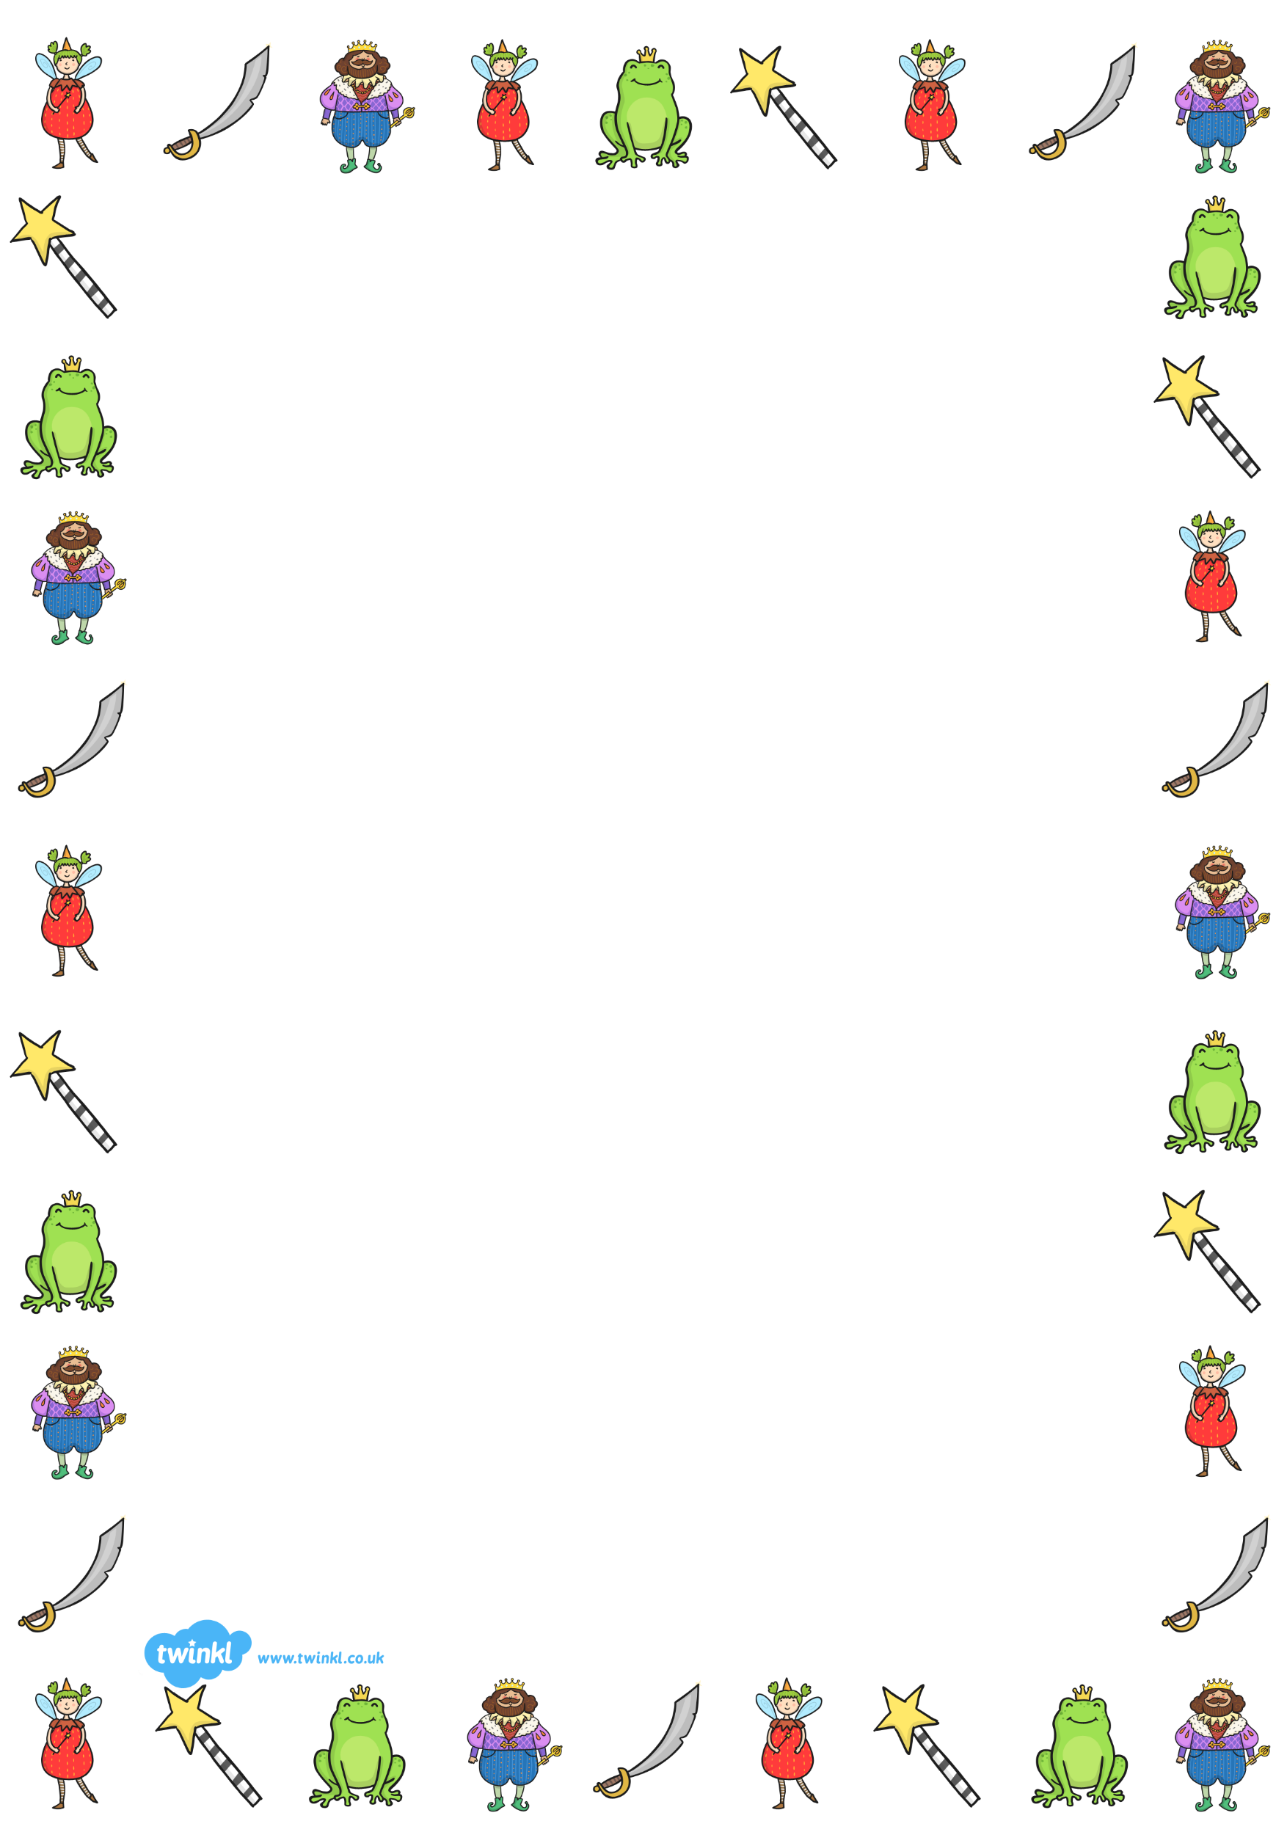
Reading Activities
- Read some fairy tales online - https://www.kidsgen.com/fables_and_fairytales/
- Here is a link to older, traditional fairy tales which may be more suitable for Year 5 and 6. These are more traditional tellings of the tales, so are a little more gory or very different (far less PC) than the tales they are familiar with, but they show how the tales have changed over time: https://www.worldoftales.com/fairy_tales.html
It might be interesting for children to pick one from the site and compare and contrast it with a version they know.
- How many words of 3 letters or more can you find in the word f a i r y t a l e s ? You can only use each of the ten letters once in each word.
What’s the longest word you can make?

KS2 - Can you work out these fairy tale anagrams?
i l e C n a l r d e h e T i b n G a r d e g e r n M a n a G t i

z u n R e p l a e h e T r e t i l L t g s P i c i l G d k s o o l

g r F o r i c P e n s n l H e a d a n l e G t e r e s k a l B t n a

KS1 - Fill in the missing letters
S _ o w W _ i t e S _ e e p i n _ _ e a u t _ _ r i n c e _ _ a r m i n g

W _ c k e d _ i t c _ B i _ B _ _ W o l _ _ _ t t l e _ e r _ a i _

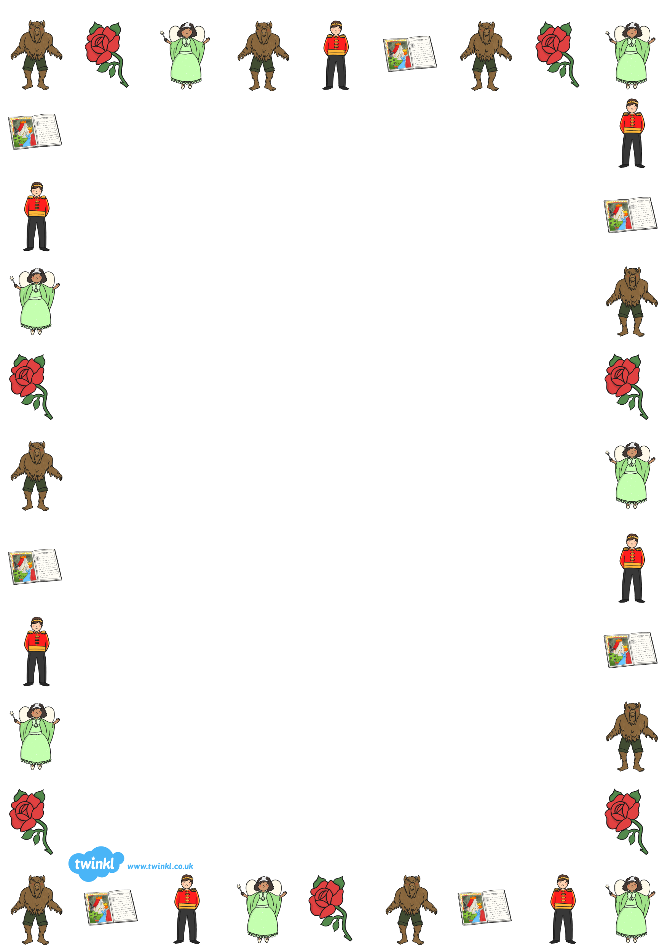

Art/DT Activities
- Make yourself a crown.
- Use an old box to make a puppet theatre http://learncreatelove.com/cardboard-puppet-theater/ - either print out and colour (or better still, draw your own) puppets or shadow puppets - put on a show for your family.
- Build a tower for Rapunzel or a fairy tale castle - use Lego, recycling (such as boxes or bottles, etc.). If you make Rapunzel's tower, remember that it has no doors. Can you invent a way for visitors to get up to the top of the tower without having to climb up Rapunzel's hair? If you make a castle, can you add a moving drawbridge or portcullis?
- You could make a shoe box scene and retell with stick puppets.
- Design your own character to star in a fairy-tale.
- Fairy tale origami: here are just a few ideas, there are many more online, some easier, some more challenging.
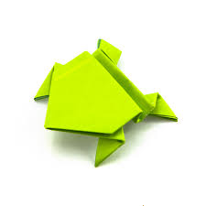 Frog Prince https://www.youtube.com/watch?v=Vlb2udqPx-M

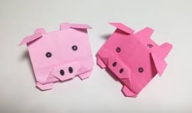 Three Little Pigs https://www.youtube.com/watch?v=KHFD2M9LRKs

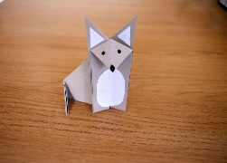 Wolf https://littleangeltheatre.com/blog/make-you-own-origami-wolf/

- Have a look at some illustrations from fairy tale books and the work of illustrators such as Arthur Rackham, Mabel Lucie Attwell, Kate Greenaway, Helen Jacobs, Jan Pienkowski etc. Choose one whose style you like and try to draw a fairy tale illustration in the same style.
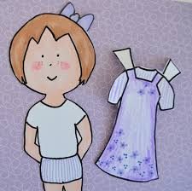
- Become a fairy tale costume designer: make Fairy Tale character dress-up paper dolls. Make a basic doll and then make a range of costumes/outfits for them (don't forget to add tabs to your costumes so that you can hook them onto your dolls and stand them up in their outfits.) There is a printable version which you can either print or look at to understand what we mean by dress up paper doll- but making your own is much more fun! You may even like to make a paper doll of yourself and turn yourself into different fairy tale characters. If you give your doll a short hairstyle, you can change the hair too.
https://babalisme.blogspot.com/2010/05/fairy-tale-paper-doll-printable.html

Drama/P.E Activities
- Use ideas from these printable cards to move around the house or garden - https://www.icanteachmychild.com/wp-content/uploads/2013/08/Action-cards-for-fairy-tale-game.pdf - you don't have to print them, you can just copy the ideas onto paper. You could add in actions for each object to make it more interesting and challenging.
- Cosmic Yoga have a variety of videos which include traditional tales and fairytales for your children to take part in : https://www.youtube.com/user/CosmicKidsYoga
- Write a play script for a part of your favourite fairy tale. Remember to include direction on how the characters should behave. Can you act out part of the story to your family? Could you involve siblings or grown-ups in the performance?

Science Activities
- Make a 'magic' colour-changing potion –
https://theimaginationtree.com/magic-colour-changing-potions-science-activity/
https://www.science-sparks.com/fairy-tale-science-experiments/

Geography
- Draw yourself a map of a fairy tale kingdom. Label all the important features – you could include castles, enchanted forests, dragon infested mountains, rivers and lakes with mermaids, witch’s cottages, dwarf mines, elf villages or anything your imagination can invent.
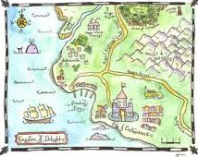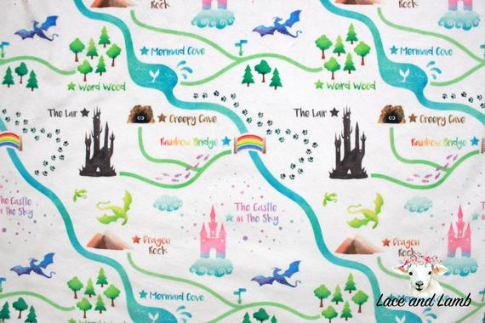

Memory game
- I went to Cinderella's castle and I took.... take it in turns to name a fairy tale object (e.g a glass slipper, a beanstalk, a bowl of porridge, etc) and try to remember what everyone has said in the correct order.

Maths
EYFS – Building Towers
- The activity: Provide children with a selection of items of various shapes. Talk about experiences of building and stacking.
- Describing: Which item are you going to put on the top of your tower? Why?
- Reasoning: How could you make your tower taller? I wonder if we could stack two shapes like this on top of each other? Which items would you use to make a very big castle? What would happen if we turned this the other way up and would it make the tower any different? If you do that, will it fall down? Can you do that without it falling down?
- Thinking: Encourage children to think about the items and their surfaces. What can be balanced and how safe is it? What if items are not in a straight line? What if you squash some together?
- Recording: Make a picture of your tower. Print a picture of your tower by dipping items in paint.

Word problems
- As a punishment, Goldilocks had to help Mrs Bear for a day. First she had to wash up their cups, bowls and spoons after breakfast.
1. How many things did she wash up?
2. Then she had to put 2 sheets, 2 pillows and a blanket on each bed. How many: pillows, blankets and sheets did she need?
3. Mrs Bear said she could stay for dinner if she put the knives, forks, spoons, plates and cups on the table. How many: knives, forks, spoons, plates and cups did she put out?
4. How many things were on the table altogether?

- Snow White is doing the washing. Each Dwarf needs 3 shirts and 2 pairs of trousers washed.
1. The washing machine only holds 10 things in 1 wash. How many things will she have to wash?
2. How many washes will she need to do?
3. If she puts 2 pegs on each item of clothing, how many pegs will she need?
4. Snow White sorts the socks into pairs. She finds 30 socks. How many pairs can she make?

- Cinderella lost her glass slipper. The Prince searched the town for her. There are 30 houses in the town, 20 houses have 2 girls in them and 10 houses have 3 girls. He found Cinderella in the last house.
1. How many girls live in the town?
2. How many feet had tried on the slipper?
3. How many toes had been in the slipper?
All the girls were invited to the wedding and had to have new shoes made.
4. How many shoes did the shoemaker have to make?
5. He could make 10 shoes a day. How many days did it take him to make all the shoes?

- Cinderella and her Prince are having a party. They send out 16 invitations. Each one is for 2 people.
1. How many people did they invite?
2. Half the people said they could not come. How many people were at the party? (Don’t forget to include Cinders and her Prince)
3. They told the cook to make sure everyone had 2 sausages; 2 pieces of pizza; 1 beef burger and lots of chips. How many sausages, beef burgers, pizza (1 pizza = 6 pieces) did she cook?
4. They had a big cake cut into 20 pieces. Everyone had a piece. How many pieces were left?

- The hen that Jack stole from the Giant laid 1 egg on a Monday, Wednesday and Friday and 2 eggs on the other days.
1. How many eggs does she lay at the weekend?
2. How many eggs does she lay in a week?
3. How many eggs does she lay in a fortnight?

Each egg weighs 20g and is worth £20.

4. How much do 5 eggs weigh?
5. How many eggs would weigh 200g?
6. How many eggs can I buy for £100?
7. How much would Jack get a week by selling the eggs?

Jack decided to have a special offer week and sold his eggs at 3 for the price of 2.
8. How much would you pay for 3 eggs?
9. I have £80 – how many eggs could I buy?

- Aladdin had 2 palaces, each one had 10 cleaners, 2 cooks and 5 waiters.
1. How many people worked in 1 palace?
2. How many people worked for him altogether?

Cleaners were paid £10
Cooks were paid £20
Waiters were paid £15

3. How many cleaners were there altogether?
4. How much did he pay altogether for cleaning?
5. How many cooks were there altogether?
6. How much did he pay altogether for cooking?
7. How many waiters were there altogether?
8. How much did he pay the waiters altogether?
9. What was most expensive: cleaning, cooking or the waiters?

