Countries
Literacy
- Transport around the world story for EYFS - https://www.youtube.com/watch?v=ERq-mX_y1Rg
- This website has online information books for children about various countries - https://www.readinga-z.com/books/themed-nonfiction-series/countries-around-the-world/ To find the right level:
Grades 1-2 = Year 2-3
Grades 3-4 = Year 4 - 5
Grades 5-6 = Year 6-7

- There is no country beginning with x - invent a new country beginning with x and make up an imaginary fact file for it. You could include climate, population, animals that live there, etc. Make up a flag for your country. Write a story set in your imaginary country.
- Famous landmarks - imagine you are either The Statue of Liberty, one of the Lions in Trafalgar Square or The Sphinx (or any other famous landmark from around the world). Write a diary about a week in your life as that landmark, what strange, funny or interesting things might happen to you?
- Pick 3 countries from different continents and write a fact file about each. This clickable world map might help. Click a country to see information about that country https://geology.com/world/world-map.shtml
Or try this website https://www.kids-world-travel-guide.com/geography-facts.html
- Although libraries are closed, there are books available on the internet from around the world. Try: Oxford Owl, Open Library and Storyline Online.
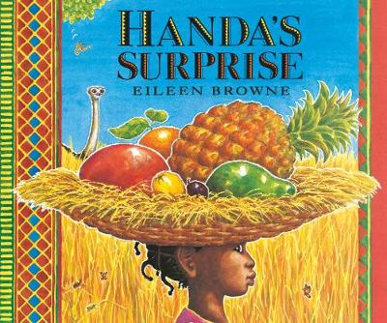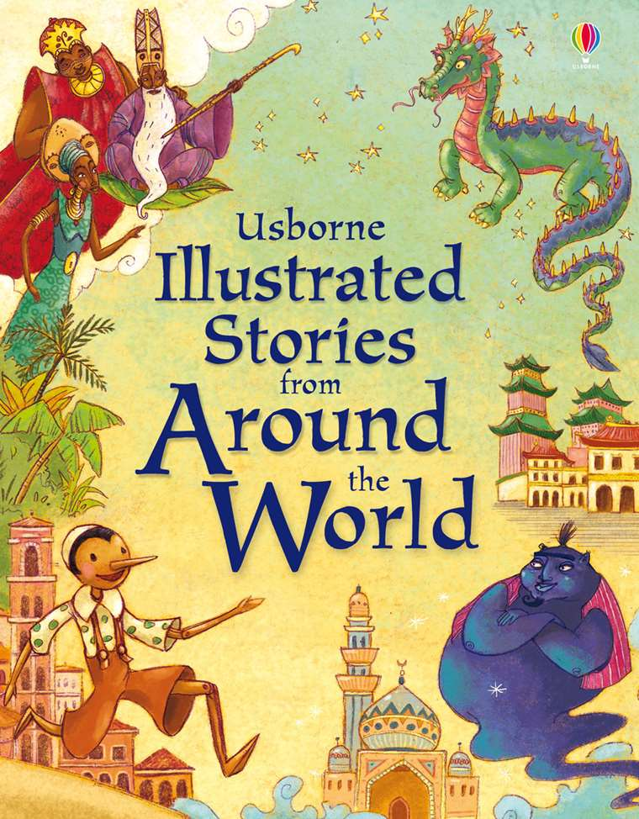

Challenge: can you learn five new words from a different language? How many countries speak that language? Or Learn to say ‘hello’ in different languages?
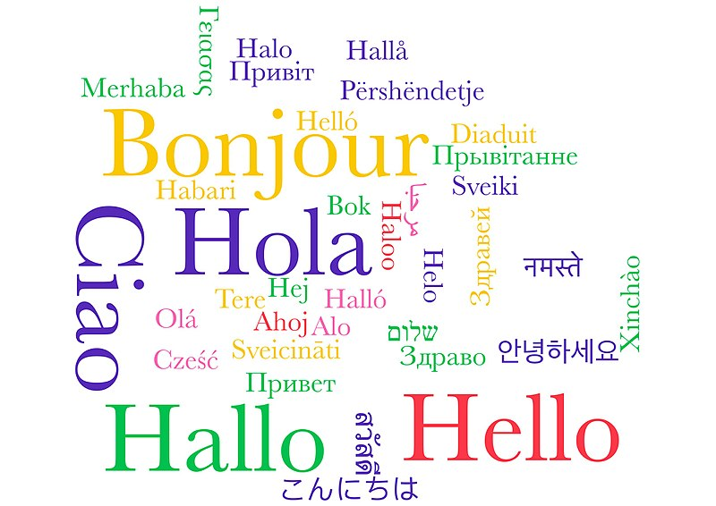

- Can you cook a native dish from your chosen country?


Games
- Play Hangman using country or capital city names.
- Alphabet of countries - try to find a country for every letter of the alphabet (except x).
- Write down as many countries as you can in one or two minutes.
- Using the list of countries you created, can you list one thing you know about each of them, e.g. something that it’s famous for: a landmark, etc.
- Have sticky notes or small sheets of paper to list things that are particular to a certain country, e.g. gum trees, pyramids. Collect all the pieces of paper and mix them up. One person picks a piece of paper – can they name the country the characteristic belongs to? For an extra point, can they provide a fact about the country?
Geography
- Can you make a fact file, travel brochure or an information PowerPoint about a country you have chosen? Perhaps you could research what the weather is like, cuisine, religions, celebrations and festivals, the population, animals and famous people.

Art Activities
- Choose a country - think about some things that country is famous for and design a stamp or a set of stamps for that country - think about the currency used in that country when you add the price in the corner. If you need a template http://www.activity-sheets.com/coloring_page/stamps/90-stamps_other-100.htm but it works just as well drawing your own stamp shape. Not all stamps are rectangular.
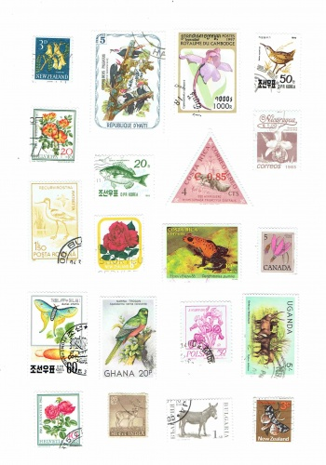
- Make a 'flags of the world' collage -
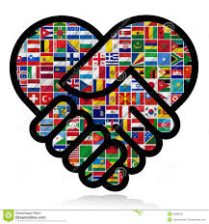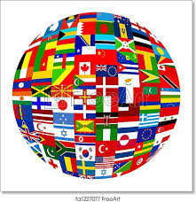
- Draw map of a country of your choice and add in the capital and large cities, geographical features such as rivers, mountains, deserts, landmarks, etc. Could you make your map 3D?
History
- Choose a country and research its history. What has it given to the world we live in now? Think about Italy and the Romans, Greece or China – ancient civilizations that have influenced us across the centuries.
- Research leaders and important figures from different countries such as Gandhi, George Washington, Mother Theresa or Nelson Mandela. How did they serve their countries and their people? How did they live their lives in all its fullness? Create a biography or fact file about them.
- Research explorers of the past such as Columbus, Cook, Mallory, Neil Armstrong.
Places that you can visit interactively
- Buckingham Palace www.royal.uk/virtual-tours-buckingham-palace
- Houses of Parliament https://www.parliament.uk/visiting/virtualtour/
- Stonehenge www.english-heritage.org.uk/visit/places/stonehenge/history-and-stories/stonehenge360/
- Giant's Causeway www.nationaltrust.org.uk/giants-causeway/features/take-a-virtual-tour-of-the-giants-causeway I love this one: you can hear the sea.
- Panoramic views of cities around the world https://www.360cities.net/

Online activities
- Guess the country https://www.msn.com/en-gb/news/newsquiz/can-you-guess-the-country-from-its-outline-map/ar-AAvpf1E Use the clickable map to help look for the country shape if you don't know it https://geology.com/world/world-map.shtml
- Bitesize KS1 Activities https://www.bbc.co.uk/bitesize/topics/zyhp34j
- Bitesize KS2 Mapping the world https://www.bbc.co.uk/bitesize/topics/zvsfr82/articles/znm7vk7
- You can explore different parts of the world on the BBC Bitesize website: https://www.bbc.co.uk/bitesize/topics/zyhp34j

Outdoor activities
- Make 3D maps using whatever materials you can found, e.g. sticks, stones, leaves. Look at the local area on Google Street view and look for features. Decide on names for the features that stick out, e.g. the wiggly jiggly path, the wise old oak tree, etc. Use the materials you found to make a map of the local area.
- Map the route you take if you go out for a walk with a family member. If you’re not able to go out, could you map a route you’re familiar with- such as how you get to school or to a grandparent’s house? Don’t forget to include landmarks- I wonder how well you can remember them?

Maths activities:

Hamilton's Puzzle

Age 7 to 11
In 1859, the Irish mathematician Sir William Rowan Hamilton devised a puzzle with a regular dodecahedron made of wood. Here is a dodecahedron:

He labelled each of the vertices with the name of an important city. The challenge was to find a route along the edges of the dodecahedron which visited every city exactly once and returned to the start.
Here is a graph which represents the dodecahedron. Can you see how each of the 20 vertices, 30 edges and 12 pentagonal faces is represented in the graph?
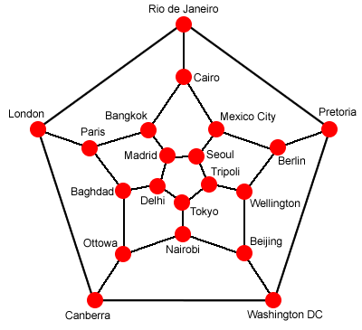
I start my journey in Rio de Janeiro and visit all the cities as Hamilton described, passing through Canberra before Madrid, and then returning to Rio. What route could I have taken?
Can you find any other ways of making this journey?
Here is a simpler network of countries:
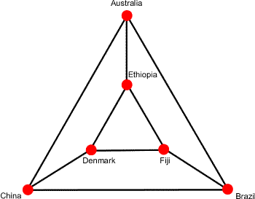
How many different ways are there of visiting each of these countries once and only once, beginning and ending at Australia?

- Maths games from around the world - https://nrich.maths.org/8261

Statistics
- Pick a country and look at some of the mathematical information such as annual rainfall, monthly hours of sunshine or population. Can you create a graph displaying the information?

Coins

Age 7 to 11
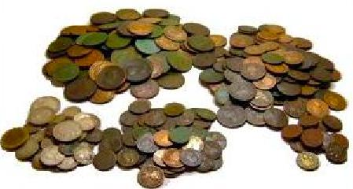
Most countries have their own currency - coins and notes.
How many different values of coins and/or notes do you have in your country?
Let's take the USA as an example - using dollars $ and cents ¢.
One dollar is equal to 100 cents.
Coins: 1¢, 5¢ , 10¢ , 25¢ , $1
Banknotes: $1 , $5 , $10 , $20, $50 , $100 .
For another example let's take India - using Rupee ₹ and Paise .
One Rupee is equal to 100 Paise.
Coins 50 & ₹1, ₹2, ₹5, ₹10,
Notes ₹5, ₹10, ₹20, ₹50, ₹100, ₹500, ₹1000
Using American currency
What is the smallest number of notes and coins (and what are they) which make a total of 12 dollars 83 cents?
What is the largest number of different notes and coins you can use to make 12 dollars 83 cents?
Using Indian currency
What is the smallest number of notes and coins (and what are they) which make a total of ₹1260 ?
What is the largest number of different notes and coins you can use to make ₹1260 ?

